Henry Chess
Year 12 Software Engineering Major Project Documentation
Advanced Desktop Chess Application

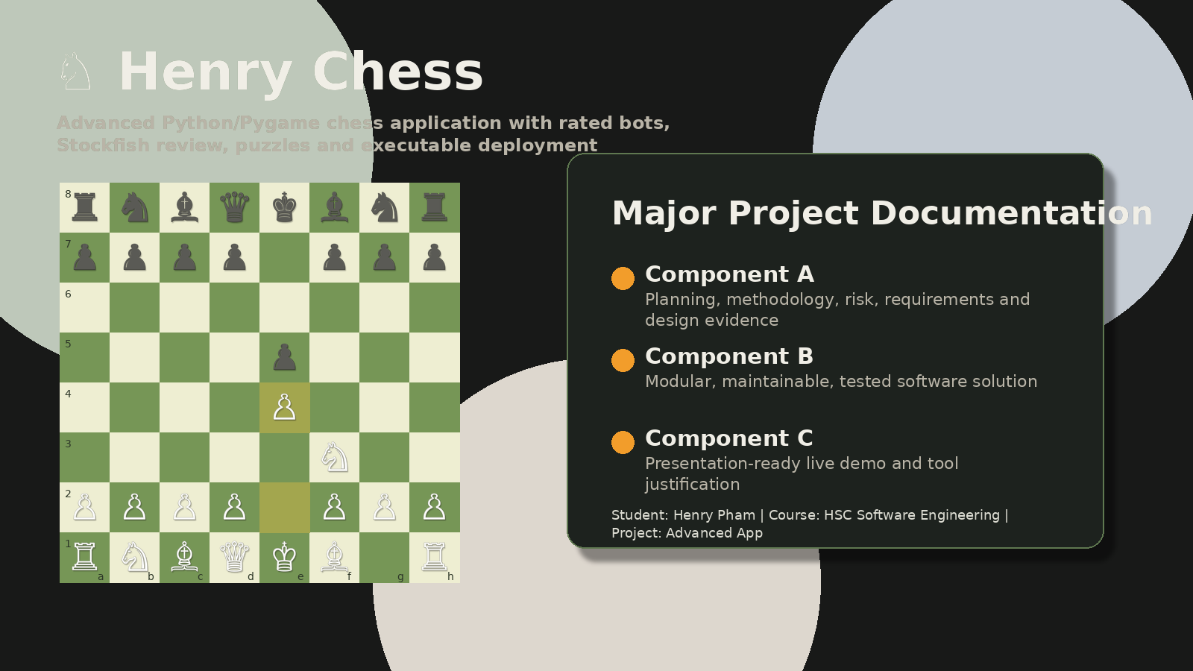
Figure 1. Project hero montage showing chess pieces, bot artwork and the major project interface style.
Item | Details
Student | Henry Pham
Course | HSC Software Engineering
School | Bonnyrigg High School
Project type | Major Project - Advanced App
Main technologies | Python, Pygame, Pytest, Stockfish UCI, PyInstaller, GitHub
Repository | https://github.com/HenryPham3023/Henry-Pham-Chess
Submission package | Source code, documentation, slides, GitHub link and executable ZIP

Authenticity note
This documentation is written to support the final submission. Screenshots and evidence sections should be checked against the final project folder and GitHub repository before submission. Any placeholder text should be replaced with final evidence if it differs from the project.

Table of Contents
- 1. Executive Summary
- 2. Assessment Criteria Mapping
- 3. Problem Definition and Project Aim
- 4. Target Users and Stakeholders
- 5. Methodology and Project Management
- 6. Tools and Technology Justification
- 7. System Requirements
- 8. Design Documentation
- 9. Implementation Documentation
- 10. Safe and Secure Programming
- 11. Testing and Evaluation
- 12. GitHub and Version Control Evidence
- 13. Deployment and Executable Access
- 14. Source Acknowledgement and Copyright
- 15. Evaluation and Future Improvements
- 16. Appendices

1. Executive Summary
Henry Chess is an advanced desktop chess application developed using Python and Pygame. The project began as a chess engine foundation and was expanded into a polished software solution that includes interactive gameplay, rated AI bots, puzzle training, visual themes, premove support, graphical annotations, Stockfish-powered game review, PGN/FEN import, executable packaging and documentation evidence. The final product is designed as an accessible chess training and playing tool for students and casual chess players.
The project addresses a real-world opportunity: many chess learners want a single offline application that combines play, practice, rules support and game review without needing to use an online account. Henry Chess provides an offline learning environment that can be demonstrated in class, shared as an executable, and extended through modular Python code.
- Local Game mode for two-player chess on one device.
- Vs AI mode using rating-style bots rather than a generic Easy/Medium/Hard system.
- Practice Bots area with multiple rating levels, including the 2250-rated Mr Zhukov bot.
- Puzzle training with automatic opponent replies and visual feedback for correct and incorrect moves.
- Stockfish Game Review that analyses player moves, shows best moves and provides accuracy-style feedback.
- Graphical annotations and premove arrows inspired by modern chess platforms.
- Executable build support so the app can be distributed outside the IDE.

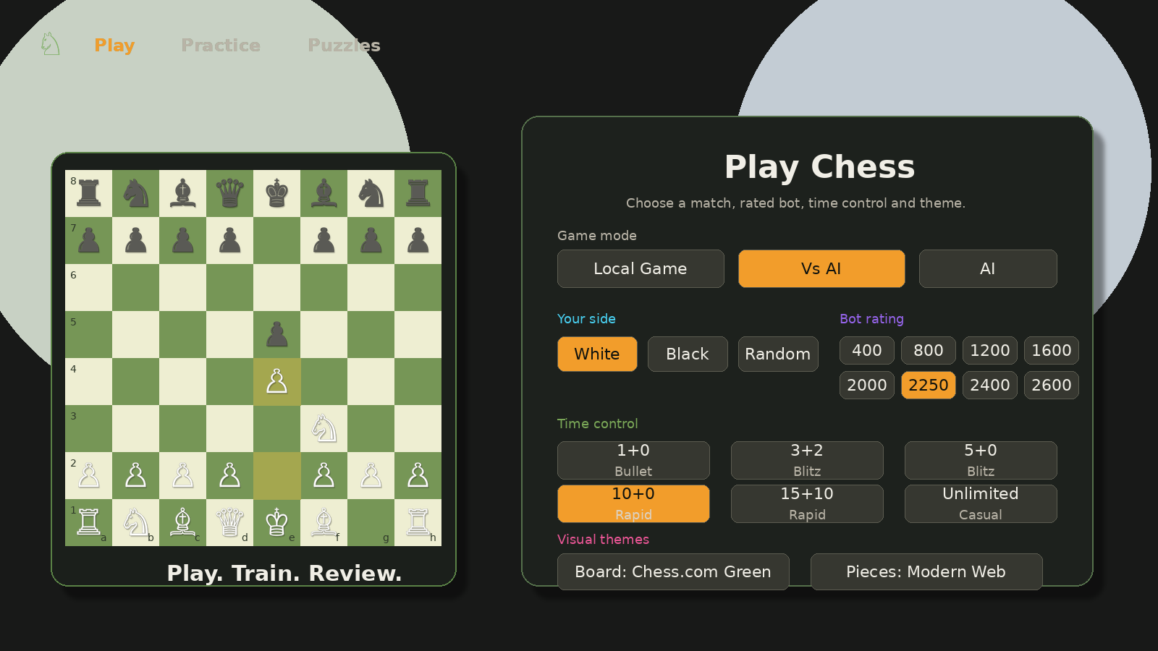
Figure 2. Play menu interface showing the main game setup controls.

1.1 Key Project Outcomes
Outcome | How it was achieved
Advanced App | The solution is an interactive desktop application with multiple screens, modes, AI logic, training tools, review tools and user settings.
Software Engineering Process | The project used an iterative WAgile style: plan core requirements first, then refine based on testing, feedback and bug fixes.
Code Quality | The final codebase is modularised into chess rules, UI/game loop, AI, game review and file handling responsibilities.
Testing and Refinement | Automated tests, compile checks and manual testing were used to detect issues such as puzzle crashes, game review loading, timer expiry and UI overflow.
Deployment | PyInstaller build support allows the game to be packaged into a downloadable executable folder.

2. Assessment Criteria Mapping
The documentation and software solution were structured around the assessment notification. The task requires a major project with documentation, a software solution and a class presentation. It also requires evidence of planning, development, testing, code structure, safe programming, GitHub use, deployment outside the IDE and a live demonstration.
Outcome | Requirement | Project evidence
SE-12-01 | Justifies methods used to plan, develop and engineer software solutions. | Methodology justification, requirements, Gantt chart, risk matrix, tools comparison, design diagrams.
SE-12-02 | Applies structural elements to build programming code. | Modular files, functions/classes, comments, PEP 8 style, meaningful names, maintainable structure.
SE-12-06 | Justifies tools/resources to design, create, manage and evaluate code. | PowerPoint, GitHub evidence, VS Code/PyCharm discussion, testing tools, Stockfish and PyInstaller justification.
SE-12-07 | Designs, develops and implements safe and secure programming solutions. | Defensive input handling, error handling, Stockfish fallback, import validation, AI threading and timer handling.
SE-12-08 | Tests and evaluates language structures to refine code. | Pytest, compile checks, manual test plan, bug fix log, optimisation notes and usability refinements.
SE-12-09 | Applies methods to manage and document the development of software solutions. | GitHub commits, README, changelog, AI usage, Stockfish documentation, code standards and deployment notes.

2.1 Component A Checklist
Requirement | Evidence in this document
[x] Consistent Table of Contents | Included as a structured documentation section.
[x] Agile / Waterfall / WAgile / DevOps | Methodologies are compared and WAgile is justified.
[x] Tools and technologies | Python, Pygame, VS Code, GitHub, Pytest, Stockfish and PyInstaller are justified.
[x] Gantt chart | Project timeline included and explained.
[x] Risk management strategies | Risk matrix and mitigation table included.
[x] Software requirements | Functional and non-functional requirements documented.
[x] Python vs Java vs Node.js | Language comparison included.
[x] VS Code vs PyCharm | IDE comparison included.
[x] Flowchart and pseudocode | Main gameplay, review and puzzle logic are documented.
[x] Class diagram | UML/module diagram included.
[x] Code copyright acknowledged | Stockfish, Pygame, tutorial base and generated assets are acknowledged.

2.2 Component B Checklist
Requirement | Evidence in project
[x] UML/design alignment | The implementation follows separated modules for chess rules, UI, AI, Stockfish review and file I/O.
[x] Formatting and naming | Python files use readable function names, docstrings and comments.
[x] Commenting/documentation | Functions and modules are documented; additional Markdown documentation is included.
[x] Code structure/modularisation | Core responsibilities are divided across main project files.
[x] Maintainability | Themes, bot profiles, board logic and review logic are isolated to allow easier future editing.
[x] Directory structure | Assets, docs, tests, engines and saved games are separated.
[x] Error handling | Invalid input, missing Stockfish, illegal moves, missing assets and timeouts are handled safely.
[x] Unit tests | Pytest test files included.
[x] At least one new feature | Multiple major features added: rated bots, game review, premove, puzzles, import, annotations and executable support.

3. Problem Definition and Project Aim

3.1 Real-World Problem / Opportunity
Chess is widely used for strategic thinking, problem-solving and pattern recognition, but many beginner and intermediate players struggle to review their own games. They often make mistakes without understanding why a move was weak, and online chess platforms may require accounts or internet access. This project creates an offline chess tool that combines playing, practising, reviewing and learning in one desktop application.

3.2 Project Aim
The aim of Henry Chess is to engineer a visually polished and functionally advanced chess application that allows users to play legal chess, practise against rating-style bots, train with puzzles, learn rules, review moves with Stockfish and run the final product as an executable outside the IDE.

3.3 Success Criteria
ID | Success criterion | Evidence
SC1 | The user can start a local or AI chess game from a clear menu. | Completed: Play menu supports Local Game, Vs AI and AI Showcase.
SC2 | The application validates legal chess moves and special rules. | Completed: legal move generation, castling, en passant and promotion are supported.
SC3 | The user can practise against bots with different strengths. | Completed: rating-style bots are used instead of generic difficulty buttons.
SC4 | The user can review a completed game. | Completed: Game Review uses Stockfish/fallback evaluation and clickable move review.
SC5 | The project is testable and maintainable. | Completed: pytest, modular files and code comments/documentation included.
SC6 | The application can run outside VS Code. | Completed: PyInstaller build script and executable packaging instructions included.
SC7 | The interface is usable and responsive. | Completed: responsive layout, scrollable move log, themes and resolution controls included.

4. Target Users and Stakeholders

4.1 User Personas
Stakeholder | Need | Project response
Beginner student | Needs to learn rules and avoid illegal moves. | Rules guide, legal move highlighting, low-rated bots, puzzles, hints.
Intermediate player | Needs tactical practice and post-game feedback. | Practice bots, puzzle mode, game review, best move arrows.
Advanced student | Needs challenging bots and Stockfish-level review. | High-rated bots, Stockfish integration, accuracy/move labels.
Teacher/client | Needs a working project that can be demonstrated and assessed. | Executable, GitHub repository, documentation, testing evidence, presentation.
Peer tester | Needs clear UI and predictable interactions. | Menus, buttons, move log, start overlay, resolution settings.

4.2 User Stories
- As a player, I want to choose my side before playing a bot so that I can practise as White, Black or Random.
- As a learner, I want legal moves highlighted so that I can understand where pieces can move.
- As a fast-time-control player, I want premoves so that I can queue a response while the bot is thinking.
- As a learner, I want puzzle feedback so that wrong moves reset and correct moves are confirmed visually.
- As a reviewer, I want to click a move in Game Review so that I can jump directly to that position.
- As a teacher, I want the app to run as an executable so that the live demo is not dependent on the IDE.
- As a developer, I want automated tests so that I can verify important chess rules after changes.

5. Methodology and Project Management

5.1 Methodology Chosen: WAgile
The project used a WAgile methodology, combining Waterfall-style planning with Agile-style iteration. This suited the project because the chess rules and assessment requirements needed to be planned clearly, while the UI, AI and usability features needed repeated testing and refinement.
Methodology point | Explanation
Waterfall strengths used | Clear initial requirements, planned architecture, Gantt chart, risk management and documentation structure.
Agile strengths used | Iterative updates based on testing: puzzle bugs, review loading, UI overflow, bot difficulty, premove behaviour and executable packaging.
Why pure Waterfall was not enough | Many UI and gameplay problems only became obvious through testing and screenshots, so refinement was needed.
Why pure Agile was not enough | The assessment required structured evidence, methodology justification, design diagrams, requirements and formal documentation.
Why WAgile fits | It supports both detailed planning and repeated refinement, which matches the project’s technical complexity and assessment criteria.

5.2 Methodology Comparison
Methodology | Description | Strength | Limitation
Waterfall | Linear planning, design, coding and testing. | Good for documentation and predictable requirements. | Too rigid for UI and gameplay bugs discovered during testing.
Agile | Short development iterations with frequent feedback. | Good for refining usability and fixing defects. | Can become disorganised without formal documentation.
DevOps | Focuses on deployment, automation and continuous delivery. | Useful for GitHub, testing and executable packaging. | Less relevant as the project is not a hosted web service.
WAgile | Combines early planning with iterative development. | Best fit: supports project documentation and repeated improvements. | Requires careful tracking so changes do not become unstructured.

5.3 Gantt Chart and Timeline
The Gantt chart breaks development into planning, engine development, UI development, AI/bot logic, training features, Stockfish review, testing, documentation and deployment. The project timeline runs from February 2026 to July 2026, reflecting an extended major project process rather than a single last-minute build.

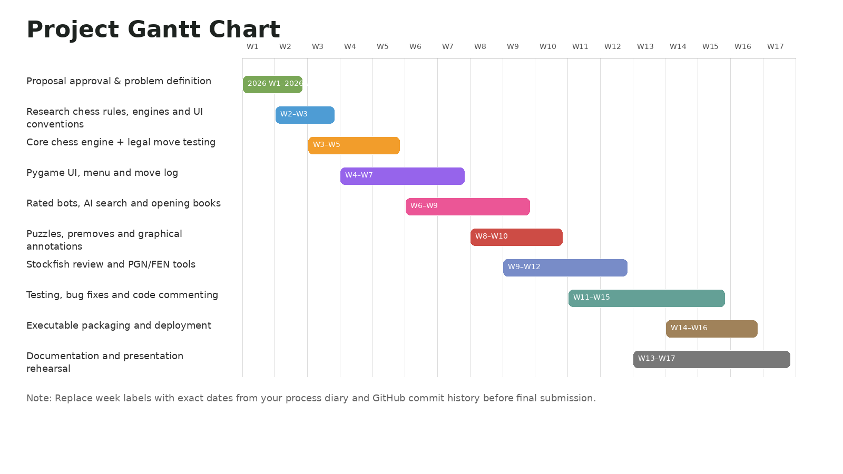
Figure 3. Gantt chart showing major development phases and milestones.

5.4 Process Diary / Logbook Summary
The following logbook provides a detailed development record. Before final submission, dates should be checked against the final GitHub history and any teacher/client feedback records. The logbook demonstrates progressive development, testing, bug fixing and documentation updates.
Period | Focus | Work completed | Evidence/output
Feb Wk 1 | Project approval and initial investigation | Reviewed project possibilities and selected a chess engine because it allowed advanced algorithms, UI design, AI and testing evidence. | Project selected; initial scope drafted.
Feb Wk 2 | Problem definition and success criteria | Defined the target users, core features and advanced extension goals such as AI bots and game review. | Problem statement and success criteria created.
Feb Wk 3 | Research and planning | Compared Python, Java and Node.js; selected Python/Pygame for desktop app development. | Technology justification drafted.
Feb Wk 4 | Chess rules architecture | Reviewed legal chess rules including castling, en passant, promotion, check, checkmate and draws. | Rule requirements documented.
Mar Wk 1 | Core engine structure | Implemented/organised GameState, board representation, move log and legal move pipeline. | Core engine functioning.
Mar Wk 2 | Move validation and undo | Tested piece movement, illegal moves and undo behaviour. | Legal movement refined.
Mar Wk 3 | Special moves | Worked on castling, en passant and promotion handling. | Special move support documented.
Mar Wk 4 | UI prototype | Built initial Pygame board rendering, move log and user click handling. | Playable prototype created.
Apr Wk 1 | AI foundation | Improved move selection logic and added bot/AI move handling. | AI move pipeline added.
Apr Wk 2 | Menu and game modes | Added Local Game, Vs AI and AI Showcase flows. | User can choose game mode.
Apr Wk 3 | Time controls | Added Bullet, Blitz, Rapid and Unlimited time options with clock handling. | Chess clock features implemented.
Apr Wk 4 | Themes and visual polish | Added board and piece theme switching; improved visual clarity. | Customisation working.
May Wk 1 | Practice bots | Added rating-style bots, bot cards and practice mode. | Bot training screen implemented.
May Wk 2 | Puzzle mode | Added puzzle data and automatic opponent replies; tested wrong-move reset behaviour. | Puzzle feature created and debugged.
May Wk 3 | Premove and annotations | Added premove arrows and right-click graphical annotations. | Advanced interaction features implemented.
May Wk 4 | Stockfish planning | Added Stockfish folder structure and UCI communication plan. | External engine design documented.
Jun Wk 1 | Stockfish review implementation | Implemented Stockfish review wrapper, move labels, accuracy logic and fallback behaviour. | Game Review functioning.
Jun Wk 2 | Review usability improvements | Added clickable move review and faster analysis of player moves. | Review became easier to navigate.
Jun Wk 3 | Testing and bug fixes | Fixed puzzle index errors, game review issues, timeout behaviour and UI overflow bugs. | Stability improved.
Jun Wk 4 | Executable packaging | Prepared PyInstaller build script/spec and executable instructions. | Deployment outside IDE documented.
Jul Wk 1 | GitHub and documentation | Updated repository, README and documentation evidence; reviewed criteria checklist. | Submission-ready evidence package prepared.
Jul Wk 2-4 | Final testing and presentation prep | Planned final dry-run tests, presentation demo order and last polish changes. | Final submission checklist prepared.

5.5 Risk Management
Risk management was important because the project had many interdependent systems: engine logic, UI state, Stockfish review, assets, executable packaging and user interaction. Risks were managed through defensive programming, tests, backups, GitHub commits and staged feature development.

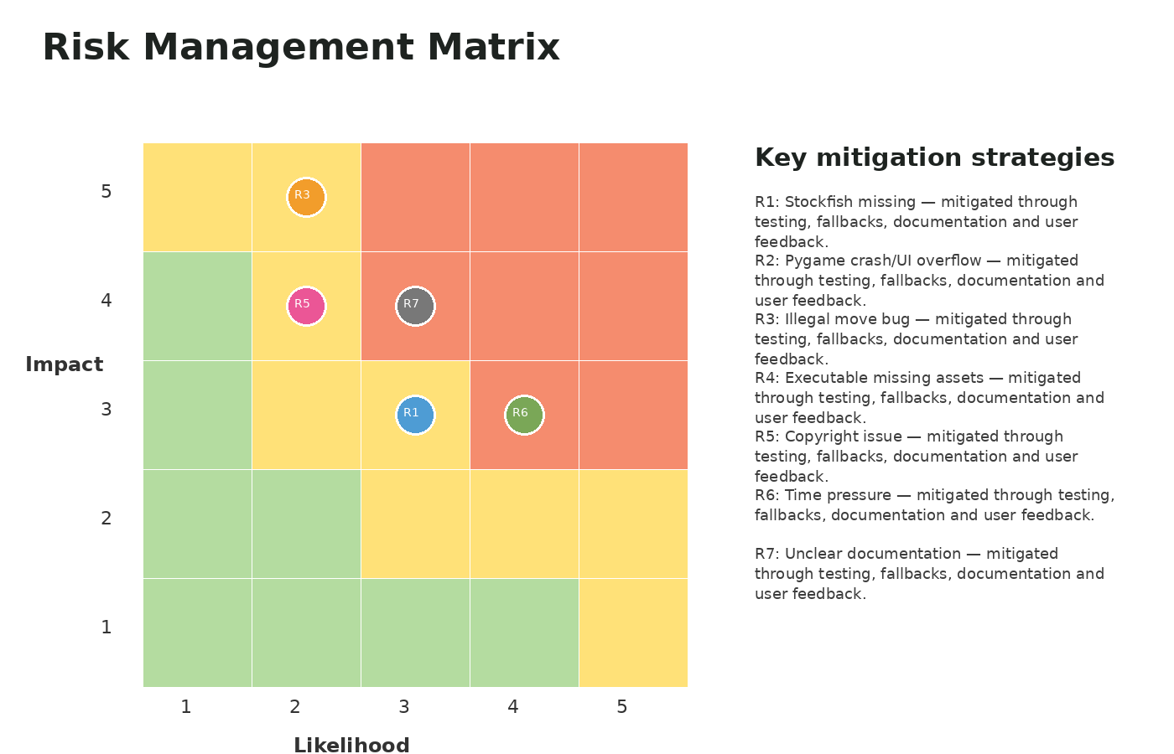
Figure 4. Risk matrix used to prioritise project risks.
Risk | Priority | Description | Mitigation | Status
Puzzle logic crash | High | Puzzle solution index could exceed available moves. | Validate puzzle_ply before reading solution; reset puzzle state safely. | Reduced after bug fix.
Game Review freeze | High | Stockfish review can take too long on long games. | Analyse human moves in Vs AI and use faster depth/time limits. | Reduced.
Stockfish missing/wrong path | Medium | External engine may not exist on another computer. | Bundle engine folders and provide fallback internal evaluation. | Controlled.
Executable missing assets | High | If only .exe is shared, pieces/sounds may be missing. | Use onedir build and instruct users to keep folder together. | Controlled.
UI overflow on different screens | Medium | Buttons or move log may spill out on small screens. | Responsive layout, clipped text, scrollable move log. | Reduced.
GitHub file too large | Medium | Executable zip can exceed GitHub file limit. | Use GitHub Releases or Git LFS; keep repository source-focused. | Controlled.
AI too weak/too fast | Medium | High-rated bots may not feel realistic. | Use rating-specific behaviour, opening books, Stockfish for high ratings and minimum thinking delay. | Ongoing refinement.

6. Tools and Technology Justification

6.1 Technology Stack
Tool | Purpose | Justification
Python | Main programming language. | Readable syntax, strong learning value, good library support and suitable for algorithms.
Pygame | Desktop graphics and interaction. | Allows custom board drawing, menus, images, sounds, clocks and mouse events.
Stockfish | Optional UCI chess engine for analysis. | Provides stronger best-move review and high-rated bot support.
Pytest | Automated testing. | Supports repeatable tests for chess rules, file handling and Stockfish fallback.
PyInstaller | Executable packaging. | Builds downloadable executable folders for users without Python.
GitHub | Version control and evidence. | Shows commit history, repository structure, README and releases.
VS Code | IDE used for development. | Supports terminal, extensions, Git integration and Python debugging.
Word / PowerPoint | Documentation and presentation. | Required for professional documentation and client handover presentation.

6.2 Python vs Java vs Node.js
Language | Strengths | Limitations | Decision
Python | Excellent readability; fast development; good for AI logic and testing; Pygame supports desktop GUI. | Pygame UI may require manual layout work; performance needs care for AI search. | Chosen.
Java | Strong object-oriented structure and desktop GUI options. | More boilerplate, slower to prototype and less suitable for quick iterative UI changes in this context. | Not chosen.
Node.js | Good for web apps and real-time servers. | Less suitable for a local desktop chess engine unless using extra frameworks; not required for offline executable. | Not chosen.

6.3 VS Code vs PyCharm
IDE | Strengths | Project decision
VS Code | Lightweight, Git-friendly, integrated terminal, flexible Python support and suitable for school project workflow. | Chosen because it supports quick testing, PowerShell/Terminal use and GitHub commits.
PyCharm | Strong Python IDE with professional debugging and project structure tools. | Useful alternative but heavier; not necessary for this project’s workflow.

7. System Requirements

7.1 Functional Requirements
ID | Functional requirement | Priority
FR1 | The system shall display an interactive chess board. | Must
FR2 | The system shall only allow legal chess moves. | Must
FR3 | The system shall detect check, checkmate and stalemate. | Must
FR4 | The system shall support castling, en passant and promotion. | Must
FR5 | The system shall allow Local Game and Vs AI modes. | Must
FR6 | The system shall allow users to choose side and time control. | Must
FR7 | The system shall provide rating-style bots. | Must
FR8 | The system shall show clocks and end games on timeout. | Must
FR9 | The system shall allow premoves against AI. | Should
FR10 | The system shall allow graphical annotations with arrows/highlights. | Should
FR11 | The system shall provide puzzle training. | Must
FR12 | The system shall automatically play opponent replies in puzzles. | Should
FR13 | The system shall provide hints only on the player’s turn. | Should
FR14 | The system shall provide a post-game review. | Must
FR15 | The system shall use Stockfish when available. | Should
FR16 | The system shall import PGN/FEN scenarios. | Should
FR17 | The system shall export PGN-style move logs. | Should
FR18 | The system shall allow theme and resolution changes. | Could
FR19 | The system shall package into an executable. | Must
FR20 | The system shall include documentation and tests. | Must

7.2 Non-Functional Requirements
Quality area | Requirement
Usability | The UI must be readable, uncluttered and controllable with mouse input.
Performance | The app targets 144 FPS and bot moves should not freeze the UI.
Reliability | Invalid moves, missing files and review errors should not close the program.
Maintainability | Code should be modular, commented and separated by responsibility.
Portability | The project should run from source and be packageable as a Windows executable.
Accessibility | Colours, labels and visual indicators should help users understand game state.
Security/safety | File imports and external engine execution should be defensive and controlled.

8. Design Documentation

8.1 System Architecture
The system uses a modular architecture. The user interface is separated from chess rules, AI logic, Stockfish analysis and file handling. This improves maintainability because a change to one feature does not require rewriting the entire project.

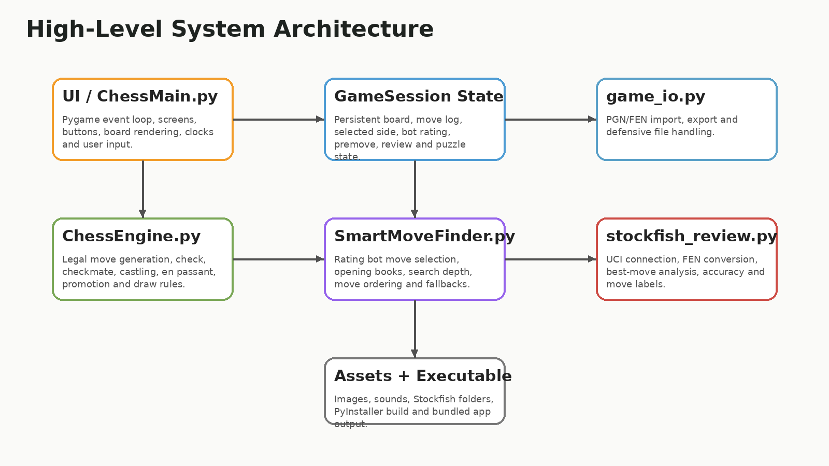
Figure 5. System architecture showing major modules and responsibilities.

8.2 Directory Structure
The directory structure separates source code, assets, documentation, tests, saved games and external engines. This supports maintainability and aligns with the assessment requirement for directory structure evidence.

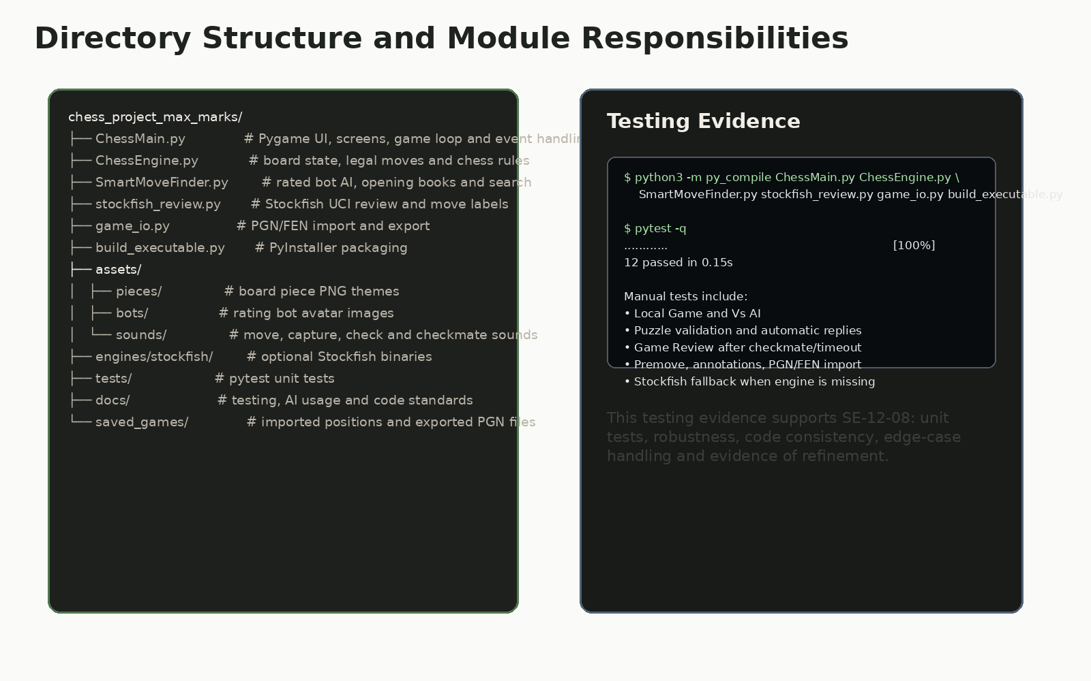
Figure 6. Directory and testing structure for the project.

8.3 UML / Class and Module Design
The UML diagram shows the major program components. The key object is GameState, which stores the board, move log, turn, castling rights, en passant state and game status. Move objects represent individual chess moves. The UI layer reads from GameState and passes selected moves through validation before applying them. SmartMoveFinder selects AI moves, while stockfish_review.py provides external review logic.

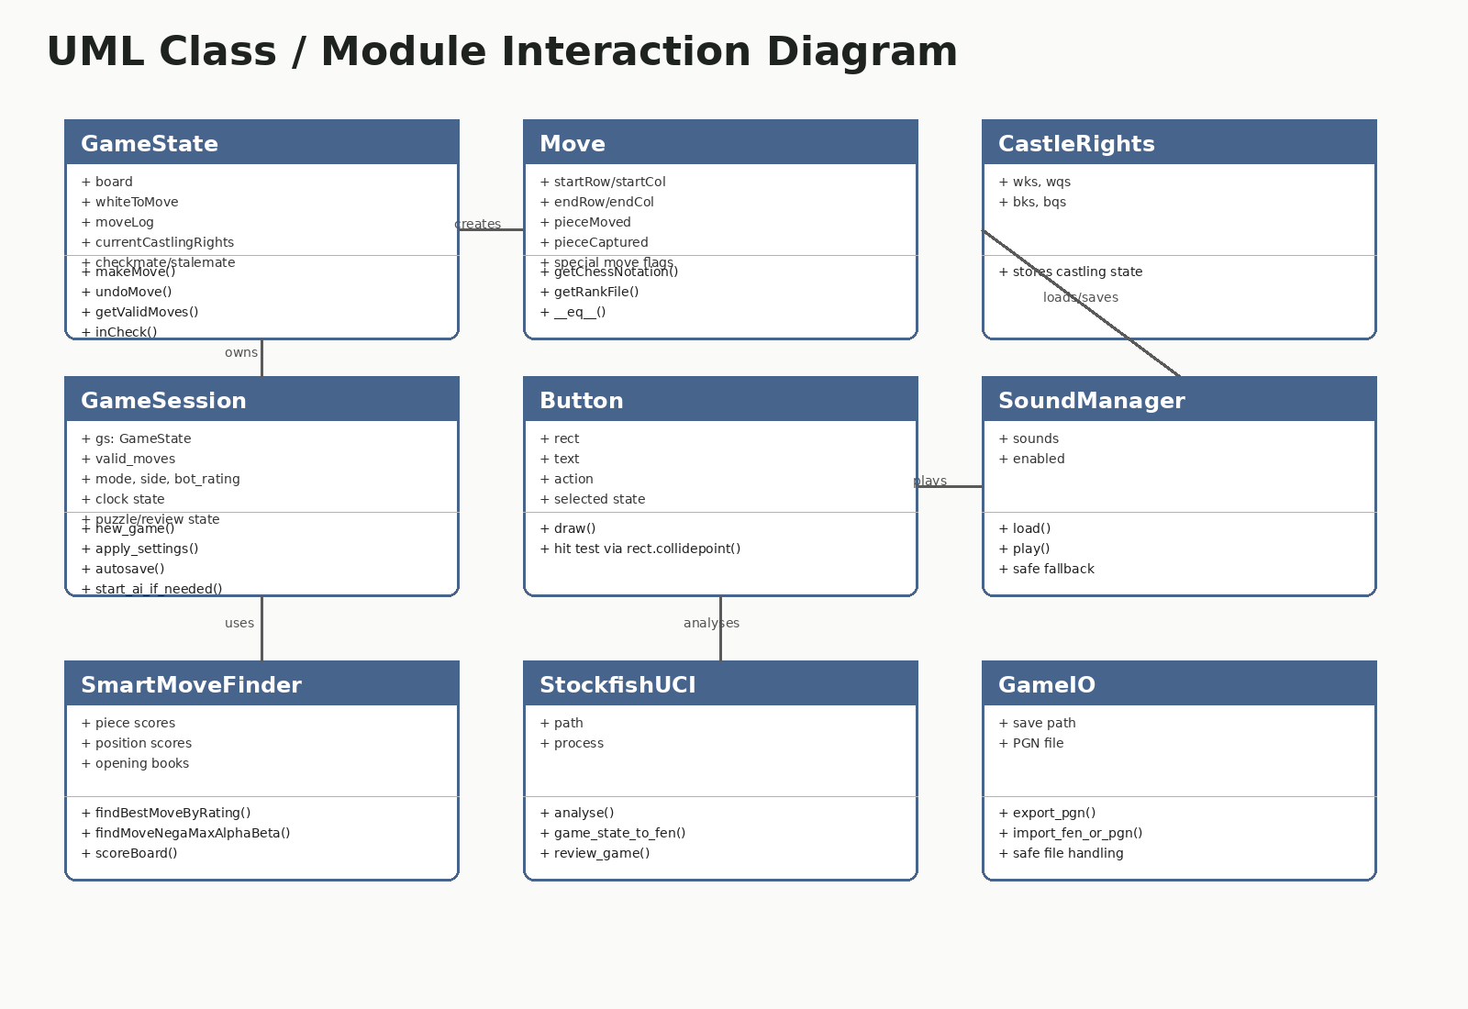
Figure 7. UML class/module diagram showing the major system components.

8.4 Interface Storyboard
The user interface is designed around clear navigation: Play, Practice, Puzzles, Rules and Tools. The layout uses large cards, visible buttons, scrollable move logs and visual feedback. This supports usability during a live demo and makes the app feel more like a complete product rather than a basic terminal chess engine.

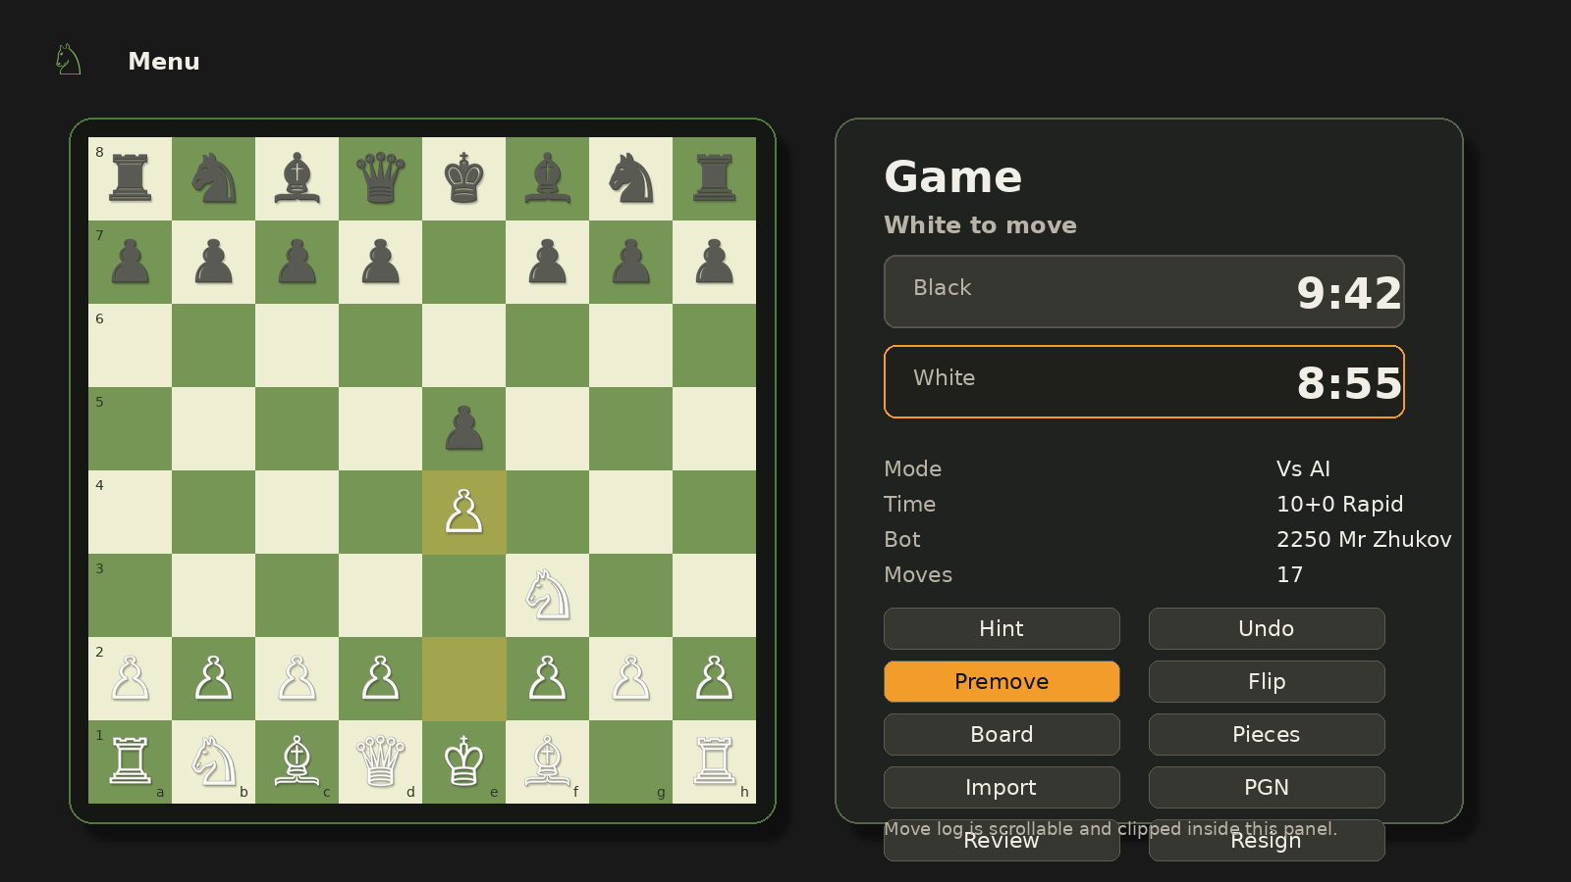
Figure 8. Main game screen showing board, sidebar, clocks, move log and controls.

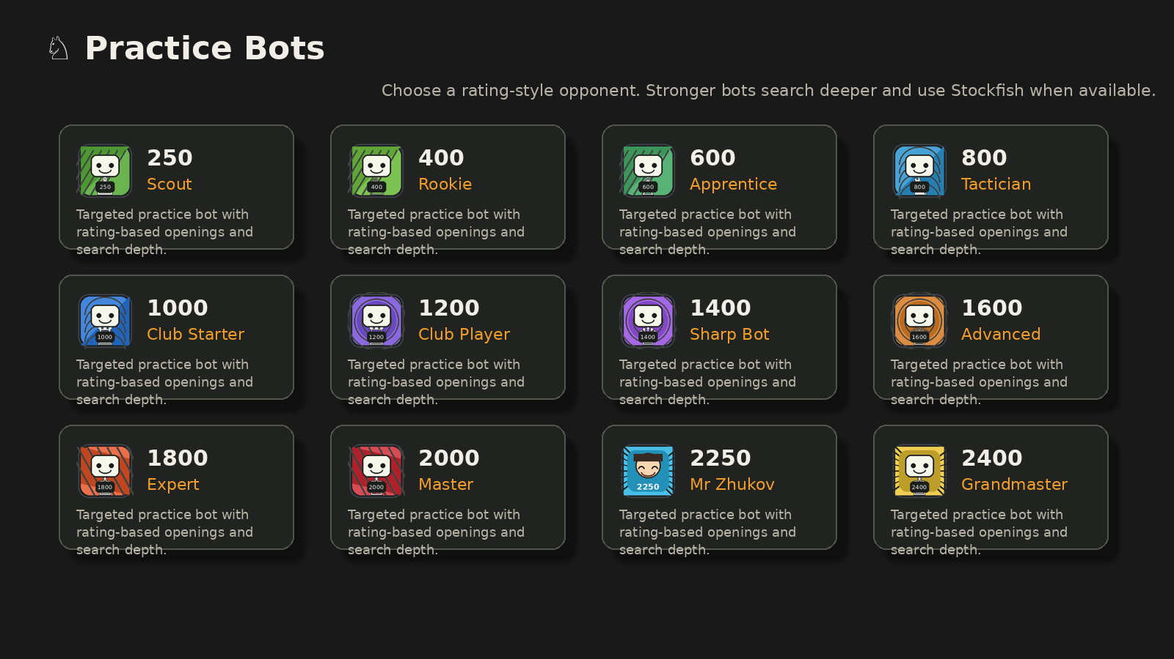
Figure 9. Practice bots screen showing rating-style training options.

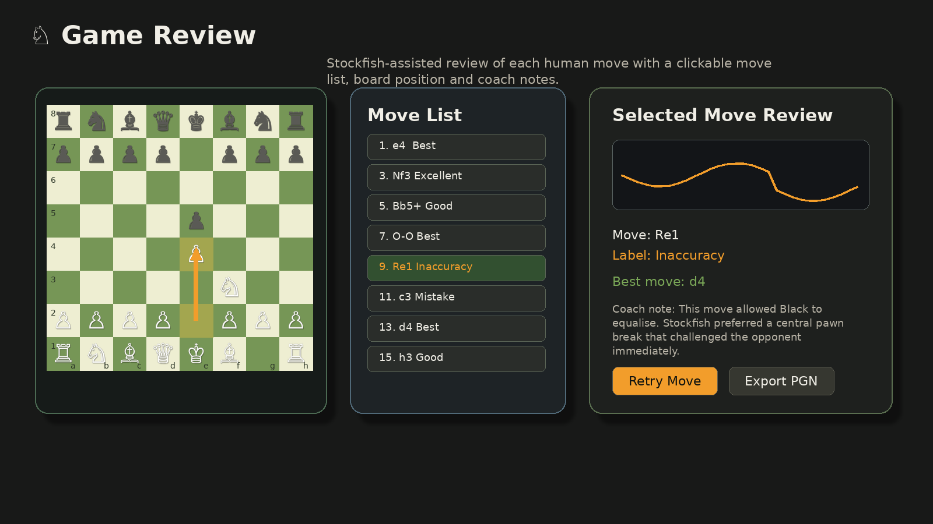
Figure 10. Game Review screen with accuracy, graph, move labels and coach notes.

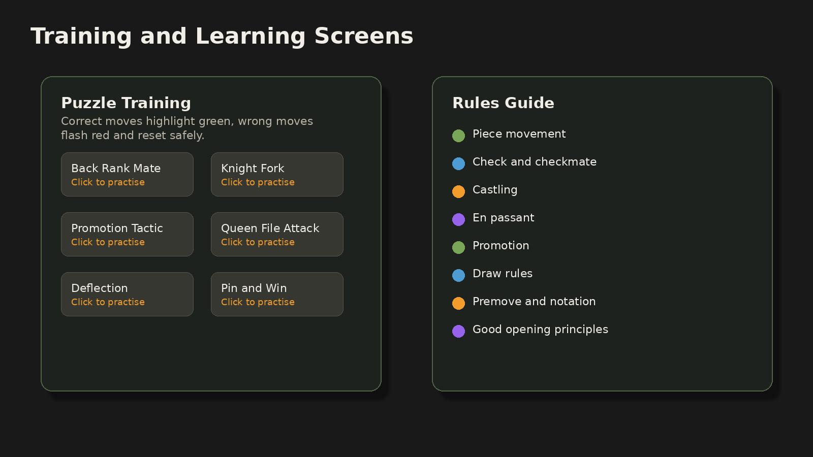
Figure 11. Training/rules interface supporting learning and usability.

8.5 Flowchart: Main Gameplay
The main gameplay flow starts with the menu, creates a persistent session, waits for the user to start the match, validates moves and updates state. If a move ends the game, the review button becomes available.

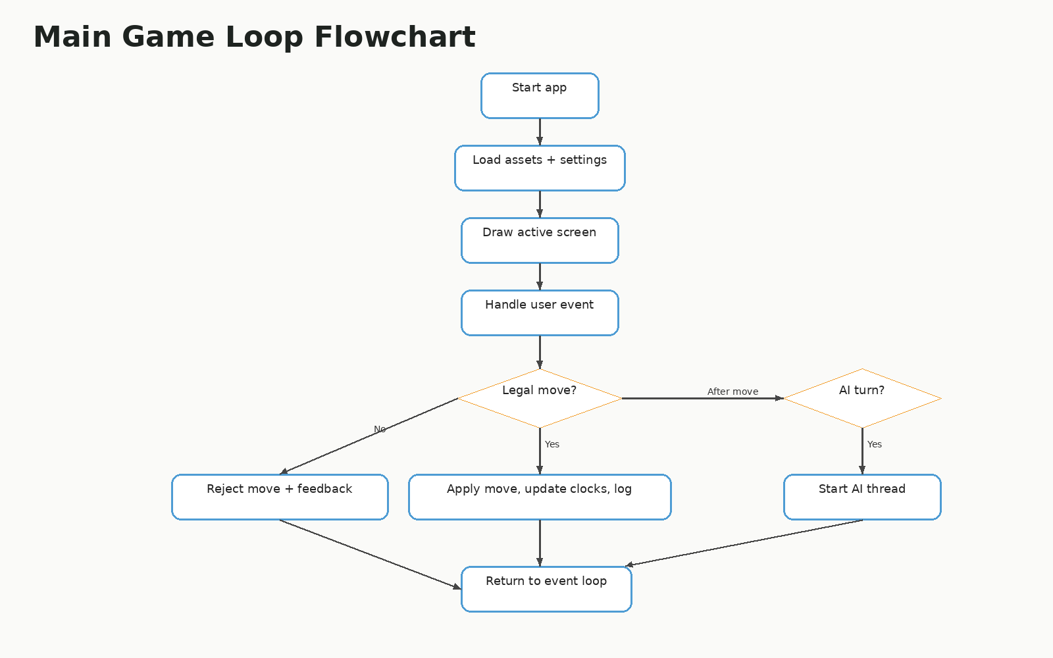
Figure 12. Main gameplay flowchart.

8.6 Flowchart: Game Review
The Game Review flow rebuilds positions from the move log, analyses player moves, labels each move and presents a clickable review list so the user can inspect individual decisions.

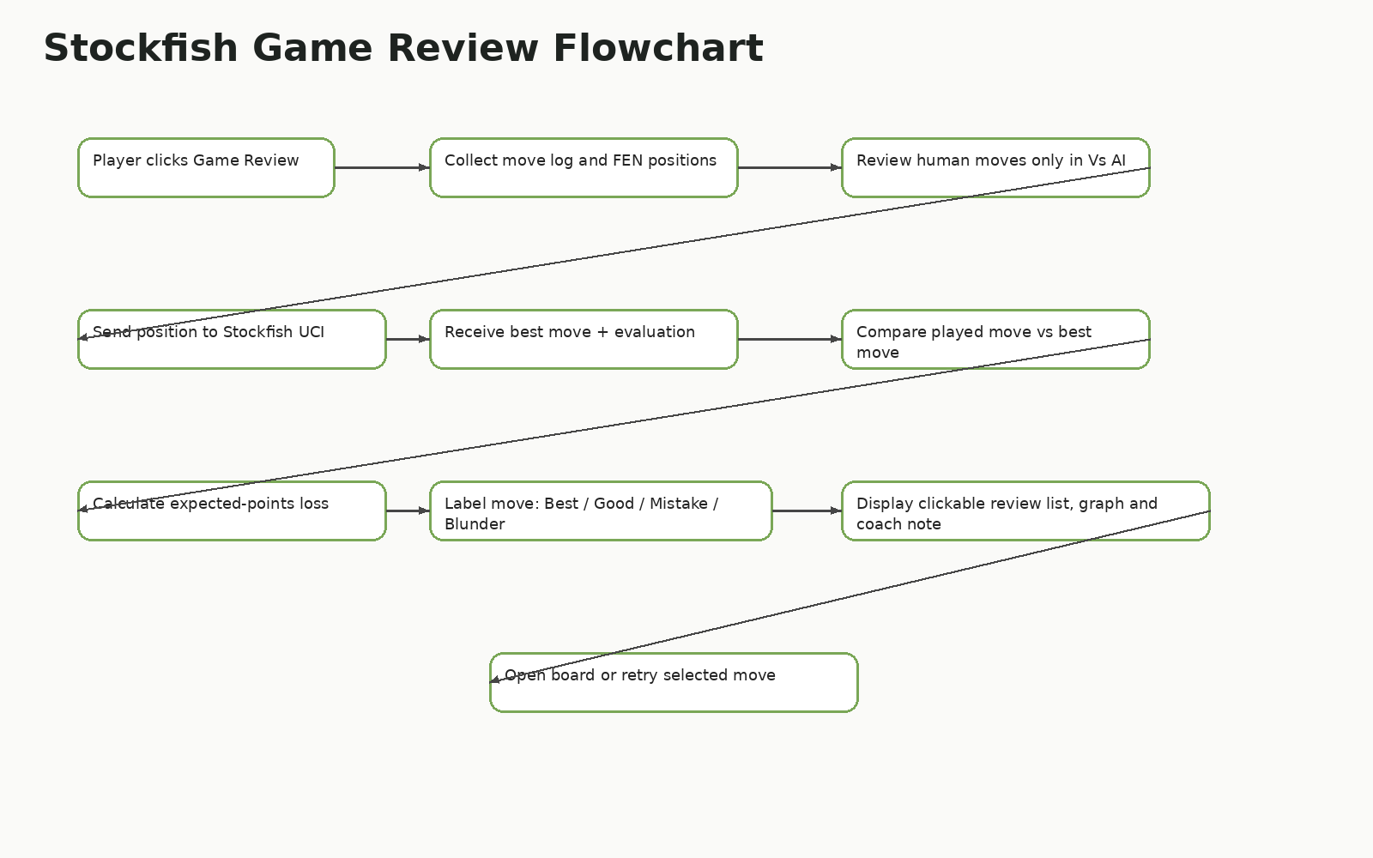
Figure 13. Stockfish game review flowchart.

8.7 Pseudocode

8.7.1 Move Validation Pseudocode
WHEN user selects a piece and destination:
create a candidate Move object
compare candidate move against current validMoves list
IF move is not legal:
reject move and show feedback
ELSE IF game is in puzzle mode:
compare move with expected puzzle solution
IF wrong move:
reset/return piece and highlight red
ELSE:
apply move, highlight green and auto-play opponent reply
ELSE IF move is a pawn promotion:
open promotion popup and wait for piece choice
apply move to GameState
update clocks, move log, valid moves and game status
IF game is vs AI and game is not over:
start AI move process

8.7.2 Rated Bot Selection Pseudocode
WHEN bot move is required:
read bot rating and time control
choose opening book based on rating and game phase
IF high-rated bot and Stockfish is available:
ask Stockfish for the best move using limited thinking time
ELSE:
use internal search with rating-based depth and randomness
wait a minimum visible thinking delay for realism
apply the selected legal move
update clocks and game state

8.7.3 Stockfish Game Review Pseudocode
WHEN Game Review is opened:
filter moves to review only the human player's moves in Vs AI
for each reviewed move:
rebuild the board position before the move
send FEN position to Stockfish
receive best move and evaluation
apply the player's move and evaluate the new position
calculate evaluation loss / expected-points loss
classify move as Best, Excellent, Good, Inaccuracy, Mistake or Blunder
store board position, played move arrow, best move arrow and coach note
display clickable move list, board, graph and accuracy summary

9. Implementation Documentation

9.1 Module Responsibility Table
File/folder | Responsibility
ChessMain.py | Main Pygame app, navigation, UI drawing, event loop, board rendering, clocks, premoves, annotations and screen state.
ChessEngine.py | Board state, legal move generation, special move rules, check/checkmate/stalemate and undo logic.
SmartMoveFinder.py | Internal AI move search, heuristic scoring, move ordering and fallback AI move selection.
stockfish_review.py | Finds Stockfish executable, communicates using UCI, analyses positions and creates review data.
game_io.py | PGN/FEN import/export, saved game handling and file safety.
build_executable.py / HenryChess.spec | PyInstaller packaging so the program can run outside the IDE.
assets/ | Pieces, sounds, bot avatars and UI assets.
tests/ | Pytest test cases for engine rules, Stockfish fallback and safety.

9.2 Major Features Implemented
Feature | Implementation detail
Legal chess engine | Validates moves using board state and generated legal moves rather than allowing arbitrary movement.
Special rules | Castling, en passant, pawn promotion, stalemate and draw logic increase rule accuracy.
Rated bots | Bots are grouped by rating and use different opening styles, thinking time and search strength.
Mr Zhukov bot | A custom 2250-rated teacher-themed bot adds personality and a project-specific feature.
Stockfish review | Uses external engine analysis for stronger feedback, best moves, accuracy and move labels.
Puzzles | Puzzle mode restricts movement to the solving side, auto-plays replies and gives green/red feedback.
Premoves | Allows users to set a premove with mouse control and visual arrows.
Graphical annotations | Right-click arrows/highlights support tactical planning and review.
PGN/FEN import | Allows custom scenarios and imported positions for testing and training.
Executable deployment | PyInstaller packaging supports running the game without opening VS Code.

9.3 Selected Code Documentation Evidence
The code contains docstrings and comments to explain the major systems. The following excerpts demonstrate the style of documentation used in the project.
def find_stockfish_path() -> Optional[str]:
"""Return a usable Stockfish executable path if one is installed.
The project first checks bundled project folders so a submitted zip can
include Stockfish without requiring a system install. It then falls back
to common system locations.
"""

def try_human_move(session, start, end, screen, clock, font_set, sound):
"""Validate a human move, handle puzzle rules, promotion and state updates.
This function is deliberately centralised so click-to-move, drag-to-move
and premove validation all follow the same legal-move pipeline.
"""

9.4 Data Structures
Structure | Description | Reason for use
Board | 2D list of strings such as wK, bQ and --. | Simple to inspect, render and test.
Move object | Stores start square, end square, moved piece, captured piece and special flags. | Allows undo, PGN-style notation and comparison.
Move log | List of Move objects. | Supports undo, review, PGN export and game reconstruction.
Bot profiles | Rating, name, description and behaviour settings. | Allows easily adding or editing bots.
Puzzle data | Position/FEN and solution sequence. | Supports puzzle validation and automatic replies.
Review entries | Move, FEN, best move, label, evaluation and notes. | Allows clickable move-by-move review.

10. Safe and Secure Programming
Although the project is a desktop application rather than a web app, safe programming is still relevant. The main concerns are invalid input, missing files, external process safety, race conditions with AI, puzzle state errors and executable packaging issues.
Safety area | Implementation response
Input validation | Only moves contained in validMoves are accepted; illegal clicks are ignored.
Puzzle validation | Puzzle index is checked so solution lists are not read past the end.
Stockfish fallback | If Stockfish is missing or fails, internal evaluation prevents the app closing.
File import safety | PGN/FEN import uses controlled paths and validates content before applying it.
AI thread safety | AI uses a safe background thread/simple move string rather than unstable multiprocessing object transfer.
Timeout handling | When clock reaches zero, the game ends and further play is blocked.
Missing assets | Images/sounds are loaded defensively and fallback behaviour prevents crashes.
Executable safety | The user is instructed to keep the dist folder together so assets and engines remain available.

10.1 External Engine Safety
Stockfish is run as a local process through the UCI protocol. The program searches known local folders first, including engines/stockfish/windows/stockfish.exe and engines/stockfish/mac/stockfish. It also supports fallback paths. This makes the app more reliable across Windows and Mac without requiring the user to manually edit code.

11. Testing and Evaluation

11.1 Testing Strategy
Testing used both automated and manual methods. Automated testing checks core logic that should not break between versions. Manual testing checks user interface behaviour, chess flow, sound, screen sizing and executable packaging, which are difficult to fully verify through unit tests alone.
Test type | Purpose
Unit testing | Pytest used for engine rules, AI fallback, Stockfish review fallback and file handling.
Compile testing | python -m py_compile checks that main files are syntactically valid.
Manual UI testing | Menus, clocks, move log, puzzles, review, themes and annotations tested through the Pygame window.
Regression testing | Previously discovered bugs were re-tested after fixes, such as puzzle crash and game review crash.
Executable testing | PyInstaller build tested outside the IDE to confirm app can launch from dist folder.

11.2 Automated Test Coverage
Test area | Expected verification
Starting legal moves | Starting board should generate the correct legal move count.
Undo | Undo should restore the board, turn and move log.
Special moves | Promotion, en passant and castling should generate and apply correctly.
Draw rules | Insufficient material, threefold repetition and fifty-move rule should be detected.
AI move selection | AI should return legal moves.
Stockfish fallback | Review functions should not crash if Stockfish is unavailable.
Game I/O | PGN/FEN import/export should handle expected file content safely.

11.3 Manual Test Matrix
Test | Steps | Expected result
Open app | Application launches without terminal error. | Pass when window appears and menu is visible.
Start Local Game | Select Local Game and Start Game. | Board opens with start overlay and local controls.
Start Vs AI | Select side, bot rating and time control. | Game starts against selected bot.
Bot movement timing | Observe bot on short and unlimited timers. | Bot waits long enough to feel realistic but does not freeze.
Move legal piece | Select piece and legal target. | Move applies and move log updates.
Illegal move | Attempt illegal target. | Move is rejected with feedback.
Promotion | Move pawn to last rank. | Promotion popup shows Queen/Rook/Bishop/Knight with images.
Premove | Enable Premove and choose future move. | Blue arrow appears and move plays if legal.
Annotation | Right-click drag on board. | Arrow/highlight appears.
Puzzle correct move | Play expected puzzle solution. | Green highlight and automatic reply if required.
Puzzle wrong move | Play incorrect solution. | Red feedback and piece returns/resets.
Timeout | Allow clock to reach zero. | Game ends and review becomes available.
Game Review | Click Game Review after game. | Move list, board pieces, accuracy and labels appear.
Clickable review move | Click a row in review list. | Board jumps to that move position.
Import PGN/FEN | Use import file or tool. | Scenario loads or fails safely with message.
Executable | Run app from dist folder. | Game opens without VS Code.

11.4 Bug Fix and Refinement Log
Issue | Cause | Fix
Puzzle IndexError | Puzzle code read solution[puzzle_ply] after the solution list ended. | Added bounds checks and safe completion state.
Game Review crash | Review tried to access a button attribute incorrectly. | Updated review button positioning and safer UI drawing.
Stockfish path issue | Stockfish executable placed in wrong folder. | Documented exact Windows/Mac paths and fallback search.
Menu overflow | Bot rating buttons spilled outside panel. | Rebuilt rating selector as a grid with clipped text.
AI instant moves | Bots moved too quickly and felt unnatural. | Added minimum visible thinking time and rating-based timing.
Timer expiry still allowed moves | Game state did not always stop after timeout. | Timeout now sets gameOver and enables review.
Hints not useful | Hints did not clearly show best move. | Hint system uses best move where available and gives clearer text.
Move log overflow | Long games drew outside sidebar. | Added clipping and scrolling.

11.5 Optimisation and Efficiency
- AI search is time-aware so short time controls do not freeze for excessive calculations.
- High-rated bots prefer Stockfish when available because it is much stronger and faster than a deep pure-Python search.
- Game Review analyses only the human player’s moves in Vs AI mode to reduce load time.
- Move lists and review data are stored so the user can click reviewed moves without re-analysing the entire game.
- The UI runs at a target of 144 FPS while keeping expensive AI/review work outside the main draw loop.

12. GitHub and Version Control Evidence
GitHub was used to manage project files and provide visible development evidence. The repository includes the README, project files, executable zip support and commit history. The uploaded screenshots show the public repository and the commit history view.

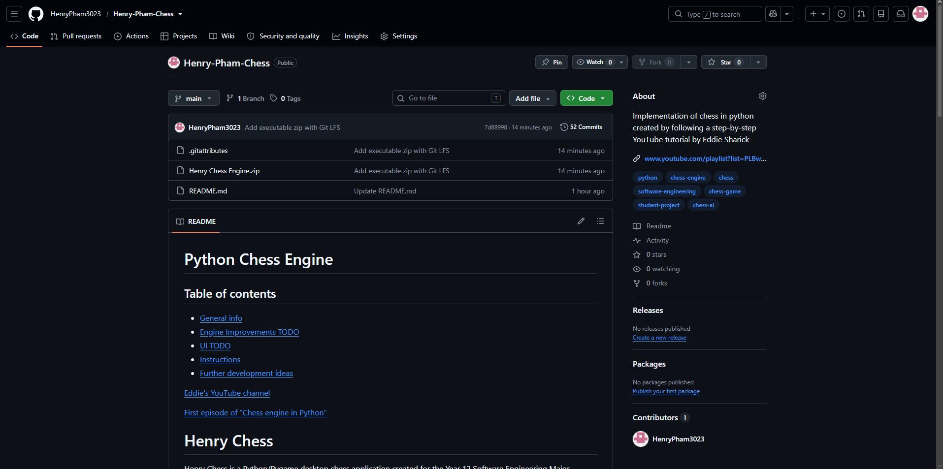
Figure 14. GitHub repository homepage showing project files, README and repository overview.

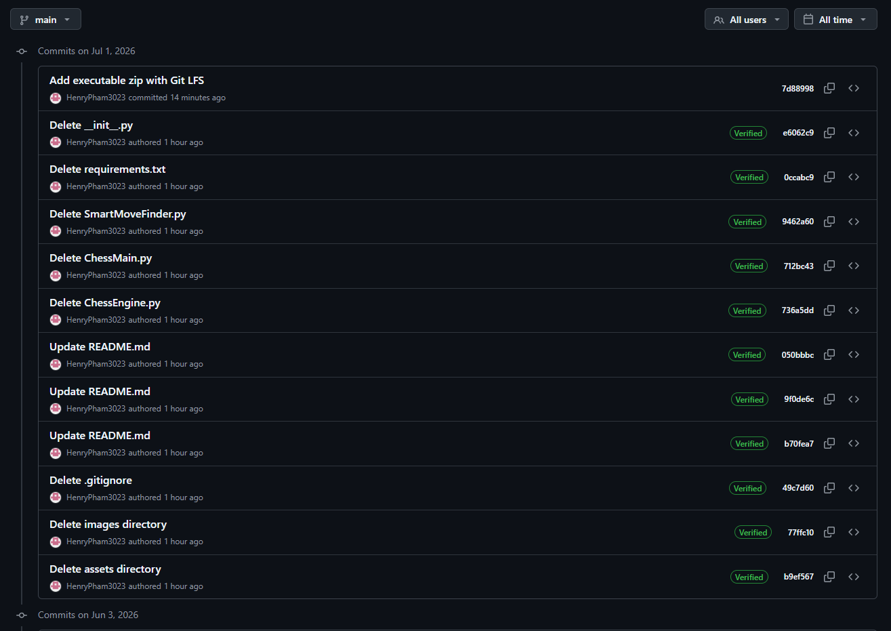
Figure 15. GitHub commit history showing version control activity.
Evidence item | Description
Repository link | https://github.com/HenryPham3023/Henry-Pham-Chess
Branch used | main
Commit evidence | Screenshot shows a visible commit history and repository activity.
Large executable handling | Executable zip handled through Git LFS or GitHub Releases as needed to avoid normal GitHub file limits.
README evidence | README provides project overview and access instructions for source/executable use.

Repository evidence note
For final submission, ensure the GitHub repository contains the final source code, README, documentation, tests and release/download instructions. If the executable zip is large, GitHub Releases is recommended rather than pushing the zip directly to normal repository history.

13. Deployment and Executable Access
The project can be run from source using Python, or packaged into a downloadable executable using PyInstaller. For a school submission, the source code and documentation should remain available, while the executable is used for a cleaner live demo and easier user access.

13.1 Running from Source
python -m pip install -r requirements.txt
python ChessMain.py

13.2 Building the Executable
python -m pip install pyinstaller
python build_executable.py

13.3 Sharing the Executable
The final executable should be shared as a compressed folder from the dist directory. The user should extract the folder and open Henry Chess.exe from inside the folder. The executable should not be moved by itself because the application needs assets, sounds, engines and supporting files.
dist/
Henry Chess/
Henry Chess.exe
_internal/
assets/
engines/
docs/

14. Source Acknowledgement and Copyright
The project acknowledges third-party tools, libraries and sources. This is necessary because the assessment requires source acknowledgement and warns against unacknowledged copied or AI-generated code. The final submission should clearly separate the original/tutorial base from the major modifications made for this project.
Source/tool | Acknowledgement
Original chess engine tutorial structure | The initial chess engine concept and structure were influenced by Eddie Sharick’s Python chess engine tutorial. The final project extends this significantly with custom UI, bots, review, puzzles, testing, deployment and documentation.
Python | Main programming language used to implement the desktop app.
Pygame | Used for rendering, input, images, sounds and the game loop.
Stockfish | Optional open-source chess engine used for move review and strong bot behaviour.
Pytest | Used for automated testing.
PyInstaller | Used for executable build support.
Generated assets | Chess pieces, sounds and bot icons are project assets and should be acknowledged in the documentation.
AI assistance | AI was used to assist with code planning, documentation, debugging and revision; outputs were reviewed and modified before inclusion.

15. Evaluation and Future Improvements

15.1 Evaluation Against Success Criteria
Criterion | Evaluation
Playable chess app | Achieved. The app supports legal moves, local play and bot play.
Advanced training features | Achieved. Practice bots, puzzles, hints, annotations and rules guide support learning.
Post-game review | Achieved. Stockfish/fallback review provides move labels, best move arrows and accuracy-style feedback.
Usability | Mostly achieved. The app includes menus, themes, resolution settings, start overlay and scrollable logs.
Reliability | Improved through repeated bug fixes, tests and defensive programming.
Deployment | Achieved through PyInstaller build support.
Documentation | Achieved through detailed project documentation, README, changelog and rubric alignment files.

15.2 Challenges Faced
- Balancing AI strength and speed was difficult because high-rated bots should not blunder, but short time controls require quick responses.
- Stockfish integration required correct executable paths and safe fallback behaviour for different operating systems.
- Pygame UI layout required repeated refinement to stop panels, buttons and move logs from overflowing on different screen sizes.
- Puzzle training required careful state management so users could not move the opponent’s pieces or continue after the puzzle ended.
- Packaging the app as an executable required careful inclusion of assets, sounds, engines and documentation.

15.3 Future Improvements
Improvement | Explanation
Online multiplayer | Could allow two users on different devices to play each other.
More puzzles | A larger puzzle database with themes such as forks, pins, skewers and checkmates.
Opening explorer | Show common opening names and opening database lines.
User accounts/statistics | Track player progress over time, bot win rates and puzzle accuracy.
Improved engine personalities | Bots could have more distinct styles such as aggressive, defensive or tactical.
Accessibility improvements | Add high contrast mode, larger text options and keyboard navigation.

16. Appendices

Appendix A: Client / Teacher Consultation Evidence Template
Use this section to record real feedback discussions. Replace placeholder rows with actual dates, names and outcomes before final submission.
Entry | Date | Feedback | Response
Consultation 1 | Date: ______ | Feedback focus: project scope and approved idea. | Action taken: refined project to advanced chess app with documentation.
Consultation 2 | Date: ______ | Feedback focus: UI/UX, testing and feature stability. | Action taken: improved menu, puzzles, Game Review and executable support.
Consultation 3 | Date: ______ | Feedback focus: final demo and marking criteria evidence. | Action taken: updated documentation, GitHub evidence, testing proof and presentation.

Appendix B: Peer Code Review Template
Reviewer | Area | Feedback | Action taken
Reviewer 1 | Usability | Menu and bot rating controls should stay inside the panel. | Rebuilt rating grid and responsive layout.
Reviewer 2 | Puzzles | Wrong puzzle moves should not require Undo. | Wrong moves are rejected/reset with red feedback.
Reviewer 3 | Game Review | Move review should be clickable rather than only Next/Previous. | Added clickable move list and stored review positions.

Appendix C: Evidence Checklist
Evidence | Notes
[ ] GitHub repository homepage screenshot | Insert final image if not already included.
[ ] GitHub commit history screenshot | Show 10+ commits over 4+ weeks if possible.
[ ] Pytest passing screenshot | Run pytest -q and screenshot terminal.
[ ] Executable running screenshot | Show app launched from dist folder.
[ ] Stockfish working screenshot | Show Stockfish terminal output or working Game Review.
[ ] Teacher/client feedback evidence | Insert real consultation evidence if available.
[ ] Peer review evidence | Insert peer testing notes or screenshots.
[ ] Final project zip/executable evidence | Show release or dist folder.

Appendix D: Bibliography / References
- Bonnyrigg High School. (2026). Year 12 HSC Software Engineering Assessment Task 3 Notification.
- Python Software Foundation. Python documentation and language reference.
- Pygame Community. Pygame library documentation.
- Stockfish developers. Stockfish open-source UCI chess engine.
- PyInstaller documentation. Packaging Python applications.
- GitHub documentation. Version control and repository hosting.
- Eddie Sharick. Python chess engine tutorial series, used as an original learning base and acknowledged source.

17. Detailed Feature Specification
This section expands the implementation evidence by explaining each major feature as a software component. The purpose is to show that the final product is not only a playable chess board, but a complete interactive desktop application with training, analysis, documentation, deployment and refinement evidence.
Feature | Purpose | Implementation | User benefit
Play Menu | Provides mode, side, bot rating, time control and visual theme selection. | Uses responsive card layout and button action identifiers. | Reduces user confusion and supports quick setup before a match.
Start Match Overlay | Prevents the AI or clocks from starting immediately when the board appears. | Game state waits for a manual start confirmation. | Makes the game feel more polished and gives players preparation time.
Local Game | Allows two players to play on the same computer. | Both sides are human controlled and use the same legal move pipeline. | Supports multiplayer demonstration without networking.
Vs AI | Lets the user choose a side and play against a rated bot. | Human/AI turn detection controls whether moves are accepted or generated. | Provides practice without requiring an online opponent.
Practice Bots | Displays rating-style bot opponents with names, icons and behaviour descriptions. | Bot ratings map to opening choices, thinking time and move selection logic. | Creates a scaffolded training pathway from beginner to advanced.
Puzzle Training | Presents tactical positions with expected solution sequences. | Player moves are checked against puzzle solution data; opponent replies are automatic. | Allows repeated tactical practice and immediate feedback.
Game Review | Provides post-game feedback similar to modern chess platforms. | Rebuilds board positions and uses Stockfish or fallback evaluator for labels. | Turns raw chess play into useful learning feedback.
Clickable Move Review | Allows selecting a move from the review list rather than pressing next repeatedly. | Review entries store FEN, move, best move and labels for direct lookup. | Improves review usability and reduces friction.
Premove | Allows a queued move while waiting for the bot. | Stores a selected move and displays a blue arrow until it is applied or cancelled. | Supports fast time controls and modern chess interaction.
Graphical Annotations | Right-click arrows and highlights can map plans and attacking squares. | Board overlay stores arrow/square annotation data and draws them each frame. | Supports analysis and presentation of chess ideas.
PGN/FEN Import | Loads custom positions or move sequences. | Input file is parsed safely and rejected if invalid. | Allows scenario testing and custom demonstrations.
Themes | Allows board and piece visual changes. | Theme arrays store colours and asset sets. | Improves user engagement and accessibility.
Resolution Tool | Lets the user change the app resolution. | Layout variables recalculate after size changes. | Improves compatibility across different computers.
Executable Build | Packages the app outside VS Code. | PyInstaller script/spec includes assets and engine folders. | Meets deployment outside the IDE expectations.
Documentation Files | README, changelog, testing, AI usage and rubric alignment support assessment evidence. | Markdown and DOCX documentation explain design and process. | Makes the project understandable to teachers, peers and future developers.

18. Use Case Specifications
The following use cases show how the main screens connect together. This provides evidence that the app was designed around user interaction rather than only code functionality.
Use case | Actor | Main flow | Successful result
UC1: Start Local Game | Player | Open app, choose Local Game, choose time control, click Start Game, click Start Match. | Board appears and both sides can be moved by the users.
UC2: Start Vs AI | Player | Choose Vs AI, choose side, choose bot rating and time, start match. | Human controls selected side and bot controls the opponent.
UC3: Choose Rated Bot | Player | Open Practice, choose side/time and click a bot card. | A training game starts against the selected rating.
UC4: Solve Puzzle | Learner | Open Puzzles, choose puzzle, play expected move. | Correct moves highlight green and opponent replies automatically.
UC5: Wrong Puzzle Move | Learner | Attempt an incorrect puzzle move. | Move is not permanently applied and red feedback is shown.
UC6: Request Hint | Learner | Click Hint during own turn. | Best move or useful suggestion is shown; disabled on opponent turn.
UC7: Set Premove | Fast player | Click Premove, choose piece and destination while waiting. | Blue arrow appears and premove applies if legal.
UC8: Review Game | Player | Finish game, click Game Review. | Review page opens with accuracy, labels, graph, board and move list.
UC9: Click Reviewed Move | Player | Click a move in the review list. | Board jumps to that position and shows played/best move arrows.
UC10: Import Scenario | Tester | Place PGN/FEN in import file and use import tool. | Custom position loads or error message appears safely.
UC11: Change Resolution | User | Open Tools and choose a resolution. | Window scales and layout recalculates.
UC12: Build Executable | Developer | Run build_executable.py. | Executable folder is created in dist for sharing.

19. Detailed AI and Bot Design
The rated bot system is designed to replace a simplistic Easy/Medium/Hard model. Ratings make the difficulty clearer to chess players and allow the software to scale bot behaviour through opening choice, thinking delay, search depth and accuracy. The highest ratings attempt to use Stockfish when available, while lower ratings deliberately use simpler calculations and more forgiving behaviour.
Rating band | Bot type | Behaviour design | Training purpose
250-600 | Beginner range | Short thinking time; simple opening moves; may overlook captures and tactics. | Learning legal moves and basic development.
800-1200 | Developing range | Looks for captures and basic tactics; uses small search depth; avoids some obvious blunders. | Training forks, pins and simple king safety.
1400-1700 | Intermediate range | More consistent development; better move ordering; fewer hanging pieces. | Club-level practice and longer games.
1800-2200 | Advanced range | Deeper internal search; stronger opening choices; Stockfish preferred if available. | Advanced calculation and positional awareness.
2250 Mr Zhukov | Teacher bot | Custom personality bot with sharper tactics and disciplined move selection. | Project-specific challenge and memorable demo feature.
2400-2600 | Expert/engine range | Stockfish used where possible; fallback uses deepest internal search. | High-strength challenge and Game Review consistency.

19.1 Bot Thinking Time Design
Instant bot moves can feel unrealistic, especially when a high-rated bot moves immediately in a complicated position. The project therefore uses minimum visible thinking time while still respecting short clocks. This improves usability and makes the bot feel more like an opponent rather than a random move generator.
Condition | Timing behaviour
Low-rated bots | Short but noticeable delay; may choose simpler moves.
Mid-rated bots | Moderate delay; searches more consistently.
High-rated bots | Longer delay when time allows; uses stronger search/Stockfish.
Bullet/blitz games | Move budget is reduced so the UI remains responsive and games remain playable.
Unlimited games | Bot can use a slightly longer search budget because there is no time pressure.

20. Detailed Stockfish Review Design
Stockfish is integrated through UCI rather than through a third-party Python wrapper. This keeps dependencies small and gives direct control over the review process. The program finds a Stockfish executable in bundled folders or system paths, starts the engine, sends positions, waits for evaluations and records the best move.
Review component | Implementation detail
Position reconstruction | The move log is replayed so the board can be rebuilt before each reviewed move.
Human move filtering | In Vs AI mode, only human moves are reviewed so the player receives relevant feedback.
Best move | Stockfish provides a best move for each analysed position.
Evaluation before/after | Position value is compared before and after the player’s move.
Move classification | Evaluation loss is converted into labels such as Best, Excellent, Good, Inaccuracy, Mistake or Blunder.
Accuracy | Accuracy is estimated from the quality of the reviewed player moves.
Board review | Each review entry stores the board position so the interface can display pieces for the selected move.
Fallback mode | If Stockfish cannot open, the app uses an internal evaluator to avoid crashing.

20.1 Example Review Data Structure
ReviewEntry:
move_number: int
side: "White" or "Black"
fen_before: str
player_move: str
best_move: str
evaluation_before: float
evaluation_after: float
label: str
coach_note: str
played_arrow: tuple[start_square, end_square]
best_arrow: tuple[start_square, end_square]

21. Detailed Puzzle System Design
The puzzle system was refined because early versions allowed the user to move the opponent’s pieces or continue after the solution list had ended. The final design treats each puzzle as a controlled sequence. The player is only allowed to move when it is their puzzle turn, and the program checks the move against the expected solution.
Puzzle stage | Behaviour
Load puzzle | Board is set to the puzzle position and puzzle_ply starts at zero.
Player move | Move is compared with the expected solution item.
Correct move | Move is applied, square feedback turns green and the next reply may auto-play.
Opponent reply | If the next solution item belongs to the opponent, the program applies it automatically.
Wrong move | Move is rejected/reset and red feedback is shown.
Puzzle complete | Puzzle state is marked solved so the program does not read beyond the solution list.
Error handling | Bounds checks prevent IndexError crashes.

22. User Manual

22.1 Starting a Match
- Open the application from Python or the executable folder.
- Select Play from the top menu.
- Choose Local Game, Vs AI or AI Showcase.
- For Vs AI, choose a side and bot rating.
- Choose the time control and themes.
- Click Start Game, then click Start Match when the board appears.

22.2 During a Match
- Left-click a piece, then left-click a legal destination square.
- Use the sidebar buttons for Hint, Undo, Premove, Flip, Board, Pieces, PGN and Menu.
- Right-click and drag to draw an annotation arrow.
- Use premove against AI to queue a move while the bot is thinking.
- If a pawn promotes, select Queen, Rook, Bishop or Knight from the popup.

22.3 After a Match
- When checkmate, resignation or timeout occurs, the game ends and Game Review becomes available.
- Click Game Review to load move labels, accuracy and coach notes.
- Click any move in the review list to jump directly to that position.
- Use arrows/best move indicators to compare the player move against the recommended move.

23. Extended Testing Appendix
ID | Area | Test | Expected result
T1 | Startup | Open application from source | Main menu appears without errors.
T2 | Startup | Open executable from dist folder | Application appears and assets load.
T3 | Menu | Select every top navigation tab | Each page opens without resetting active game unexpectedly.
T4 | Menu | Choose each time control | Selected time control appears in status line.
T5 | Menu | Choose 2400/2600 bot rating | Rating chip stays inside menu panel.
T6 | Board | Move e2-e4 in local game | Pawn moves and move log records e4.
T7 | Board | Attempt illegal rook diagonal move | Move is rejected.
T8 | Board | Flip board | Coordinates and pieces change perspective.
T9 | Board | Draw annotation arrow | Arrow remains visible until cleared or screen resets.
T10 | Premove | Set premove while waiting | Blue premove arrow appears.
T11 | Premove | AI move makes premove illegal | Premove cancels safely.
T12 | Clock | Start 1+0 game | Clock counts down correctly.
T13 | Clock | Clock reaches zero | Game ends; no further moves accepted.
T14 | AI | Play 400 bot | Bot is forgiving and may miss tactics.
T15 | AI | Play 2400 bot with Stockfish | Bot produces strong legal moves.
T16 | Puzzle | Play correct first move | Green feedback and/or auto reply appears.
T17 | Puzzle | Play wrong move | Piece returns and red feedback appears.
T18 | Puzzle | Complete puzzle | Puzzle stops without IndexError.
T19 | Review | Open review after checkmate | Review opens and does not close game.
T20 | Review | Click move in review list | Board updates to chosen move.
T21 | Review | Stockfish missing | Fallback review appears or clear message is shown.
T22 | Import | Import valid FEN | Board loads scenario.
T23 | Import | Import invalid text | Program rejects file safely.
T24 | Themes | Cycle board theme | Board changes colours without changing game state.
T25 | Sounds | Move/capture/checkmate sounds | Audio plays without error or disables safely if unavailable.
T26 | Build | Run PyInstaller build | dist folder is created.
T27 | GitHub | Check README instructions | A new user can follow download/run instructions.
T28 | Documentation | Open project documentation | All key criteria are documented.

24. Presentation / Live Demo Plan
The presentation should tell the story of the project: problem, planning, implementation, testing, challenges, final product and reflection. The live demo should focus on features that are easy to see and that prove the app is advanced.
Slide | Focus | What to show
1 | Title and problem | Explain that the project is an offline chess training app.
2 | Project requirements | Show how the app addresses the assessment criteria.
3 | Methodology | Explain WAgile and how testing changed the project.
4 | Architecture | Show module structure and UML.
5 | Play menu demo | Choose Vs AI, side, bot rating and time control.
6 | Gameplay demo | Make a move, show legal highlights and move log.
7 | Special features | Show premove, annotations, promotion and themes.
8 | Practice/Puzzles | Show rating bots and puzzle feedback.
9 | Game Review | Show Stockfish labels, best move arrows and clickable move list.
10 | Testing | Show pytest and bug fix evidence.
11 | Deployment | Show executable running outside the IDE.
12 | Reflection | Discuss challenges and future improvements.

25. Final Full-Marks Evidence Checklist
Component | Criterion | Evidence | Status
Component A | Methodology | WAgile justified and compared with Waterfall/Agile/DevOps. | [x]
Component A | Planning | Gantt chart, requirements, risk matrix and process diary included. | [x]
Component A | Tools | GitHub, Word, PowerPoint, Python, Pygame, Stockfish, PyInstaller and Pytest justified. | [x]
Component A | Design | UML, flowcharts, pseudocode, UI storyboard and directory structure included. | [x]
Component A | Management | GitHub evidence and documentation evidence included. | [x]
Component B | Code structure | Modular files, responsibilities and data structures explained. | [x]
Component B | Comments | Docstrings and code documentation discussed. | [x]
Component B | Secure/safe programming | Defensive handling, external engine safety, import validation and timeout handling included. | [x]
Component B | Testing | Automated and manual testing evidence described. | [x]
Component C | Presentation | Demo plan and slide structure included. | [x]
Submission | Executable | Build and sharing instructions included. | [x]
Submission | Acknowledgement | Third-party and AI assistance acknowledgement included. | [x]

17. Template-Aligned Documentation Expansion

Purpose of this additional section
This section extends the existing major project documentation by directly aligning the chess engine evidence with the newly supplied school documentation template. The template emphasises a complete cover page, automatic table of contents, problem statement, software methodology, requirements analysis, stakeholder analysis, Gantt planning, technology justification, high-level architecture, UML, flowcharts, pseudocode, wireframes, directory structure, secure programming, testing, GitHub management, logbook evidence and reflection. This expansion therefore acts as a final standards cross-check so the submitted documentation clearly demonstrates planning, implementation, testing, refinement and deployment.

Template crosswalk
Template requirement | How the Henry Chess documentation addresses it
Cover page | The documentation includes project title, course, student details, GitHub link, submission details and version information. The title page identifies the solution as an advanced desktop chess application.
Table of contents | A structured table of contents is included. Headings are also formatted using Word heading styles so the TOC can be updated in Microsoft Word before final submission.
Introduction | The project problem, purpose, target users, educational benefits and project success criteria are explained in detail.
Project planning | WAgile methodology, sprint milestones, Gantt chart, risk management, stakeholder feedback and process diary sections are included.
Requirements analysis | Functional and non-functional requirements are expanded with acceptance criteria and testing methods.
Technology justification | Python, Pygame, VS Code, GitHub, PyInstaller, pytest, Stockfish and documentation tools are justified.
Design documentation | High-level architecture, module responsibilities, UML, flowcharts, pseudocode and UI storyboard evidence are included.
Secure programming | Desktop-app safety is addressed through validation, defensive file handling, exception handling, Stockfish fallback and threading controls.
Testing | Manual testing, unit testing, edge-case testing, performance testing and regression testing are described.
GitHub management | Commit history, GitHub repository structure and downloadable executable strategy are documented.
Reflection | Challenges, solutions, lessons learnt and future improvements are evaluated.
Before submission, right-click the Word table of contents and select Update Field to refresh page numbers after final edits.

18. Expanded Introduction and Project Context

18.1 Problem statement
Many school-level chess programs are either too basic for serious practice or too complex for younger and intermediate learners. Web platforms such as chess.com and Lichess provide high-quality features, but they require accounts or internet access and may include distractions that are not suitable for a controlled school project environment. The opportunity addressed by Henry Chess is to create an offline desktop chess application that combines legal chess gameplay, rated practice bots, puzzle training, Stockfish-assisted review, premoves, annotations and beginner-friendly rules in one accessible program.
The problem is not simply to draw a chess board. A complete chess application must validate legal moves, prevent illegal self-check, support special rules, manage clocks, respond to player input, run AI moves without freezing the interface, present feedback clearly, store or export game data and provide useful learning tools. This project therefore demonstrates software engineering through both algorithmic logic and user-centred interface design.

18.2 Purpose and educational value
Henry Chess was designed for students, classroom demonstrations, chess club practice and school tournament preparation. Its educational value comes from the way it turns chess into an interactive learning environment rather than only a playing board.
- Students can practise against rating-style bots rather than only playing another human.
- Beginners can use hints, rules pages and puzzle training to understand why a move is effective.
- More experienced users can use Stockfish review to evaluate accuracy, mistakes and best moves.
- Teachers can demonstrate move legality, special chess rules, tactical arrows and review feedback during lessons or club sessions.
- The application can run locally as an executable, making it suitable for a school environment where internet access may not always be available.

18.3 Brief chess and software context
Chess has long been used as a way to teach strategic thinking, pattern recognition and decision-making. In computing, chess is also a classic artificial intelligence problem because a chess program must evaluate board states, search possible moves, choose strong candidate moves and respond within time constraints. This made a chess engine an appropriate project for Software Engineering because it required data structures, algorithms, modular design, testing, user interface development and external tool integration.

18.4 Current interface evidence
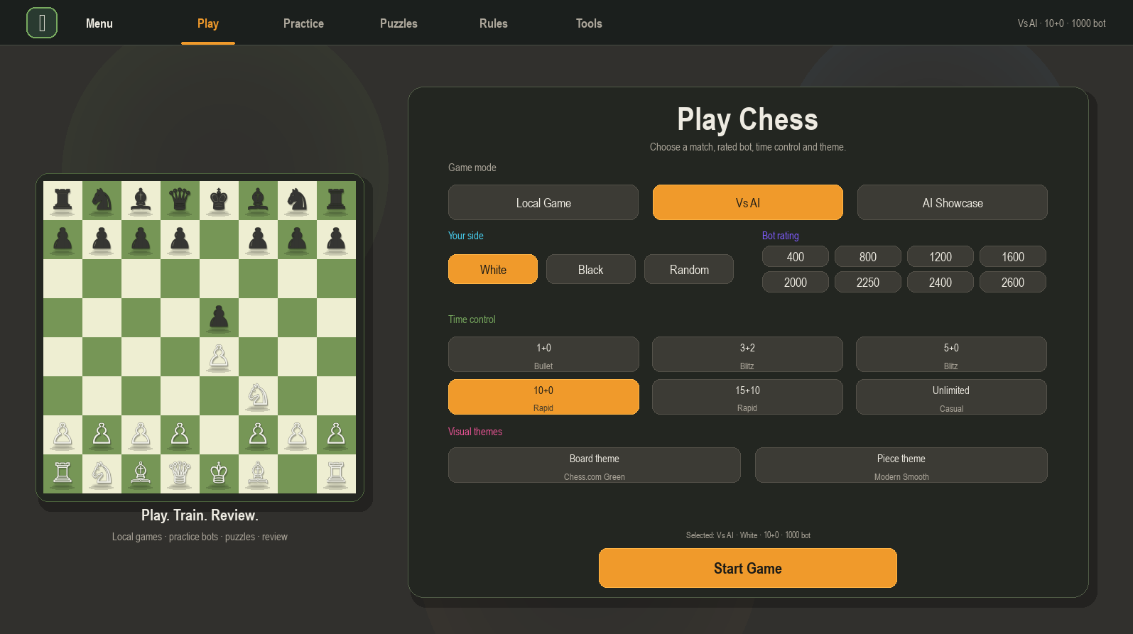
Figure 17.1. Final Play menu showing game mode, side selection, bot rating, time control and visual themes.
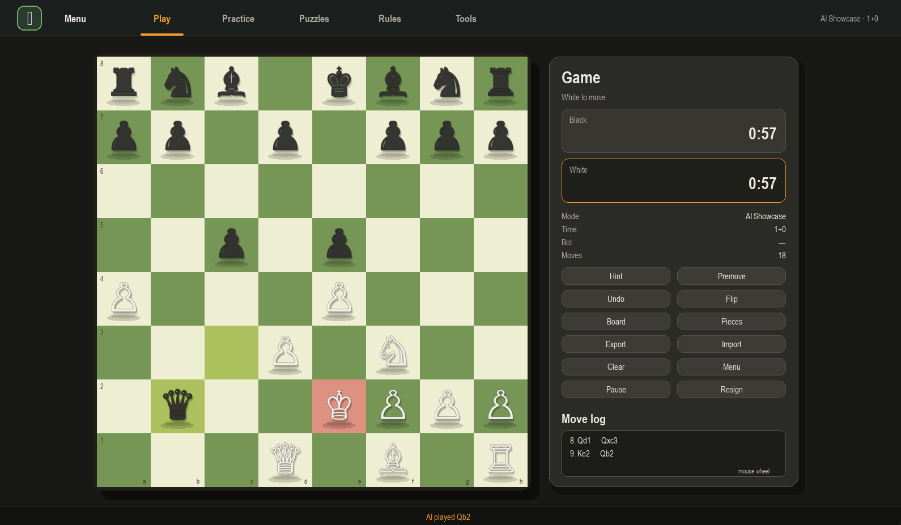
Figure 17.2. Main gameplay screen with board, clock system, move log, sidebar controls and AI gameplay.
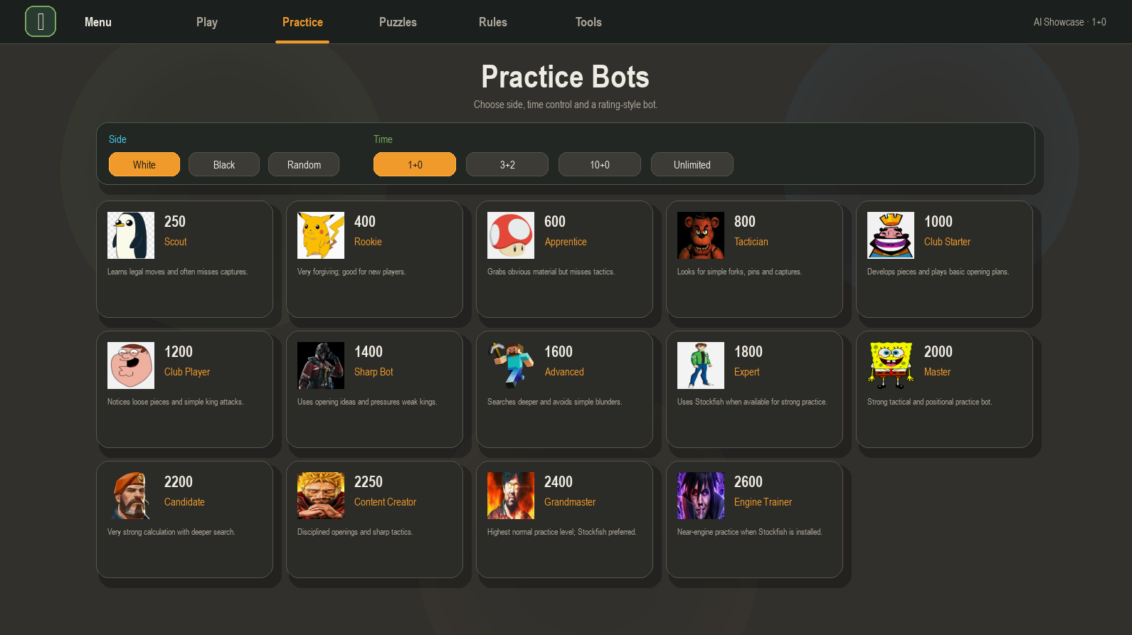
Figure 17.3. Practice Bots screen showing rating-style bots and selectable practice conditions.
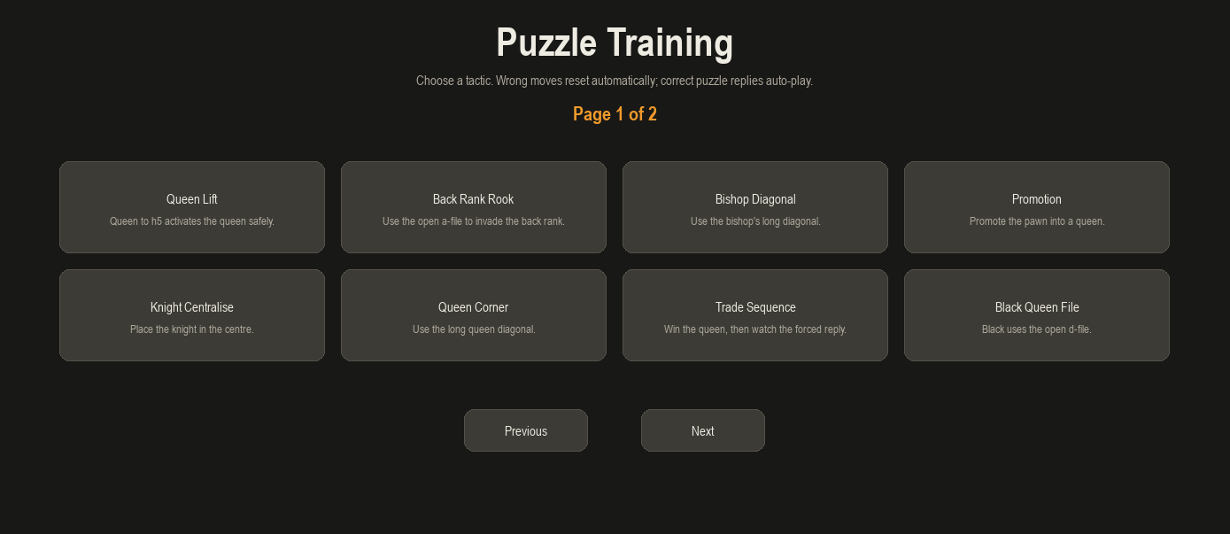
Figure 17.4. Puzzle Training screen with multi-page tactical puzzle selection.
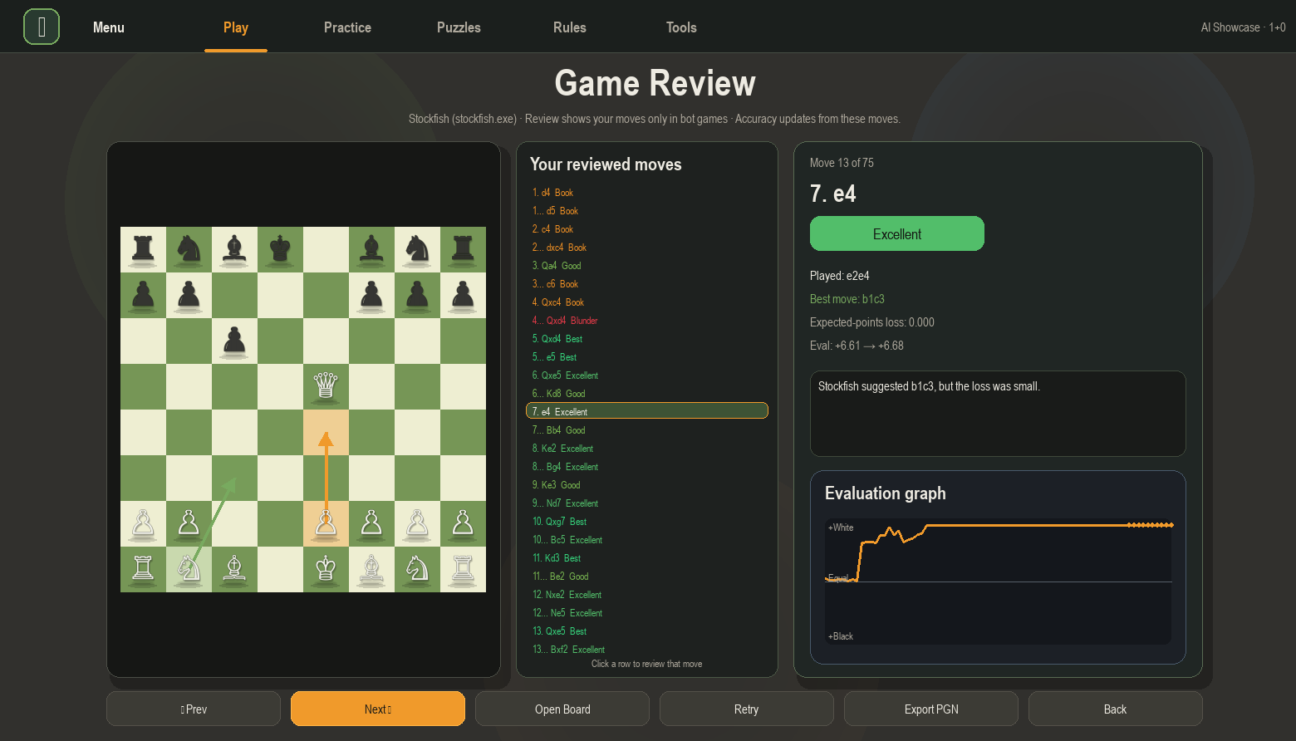
Figure 17.5. Stockfish-assisted Game Review showing board state, clickable reviewed moves, move label, coach note and evaluation graph.
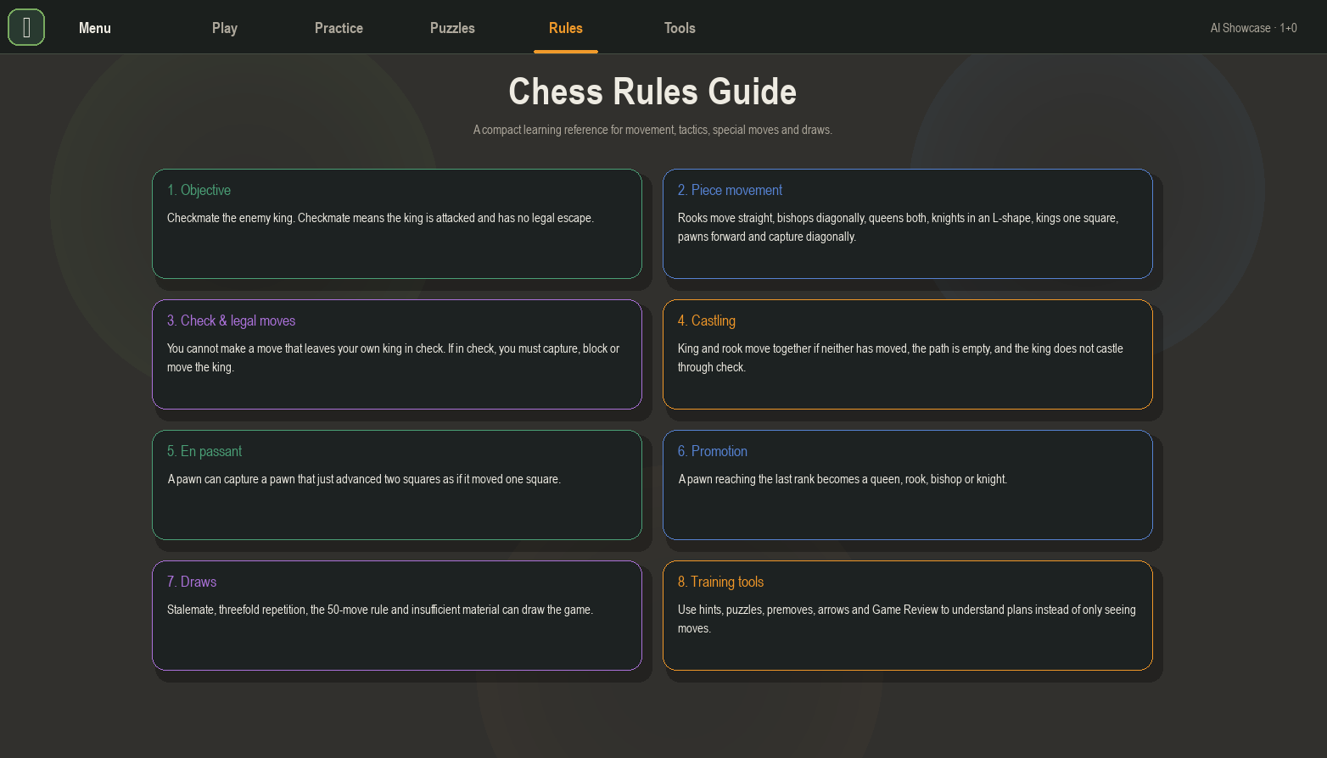
Figure 17.6. Rules Guide screen explaining movement, special rules, draws and training tools.

19. Expanded Project Planning

19.1 Methodology justification: WAgile
The project used a WAgile approach, combining the structure of Waterfall planning with the flexibility of Agile iteration. This was suitable because the core chess rules were known from the start, but the interface, bot system, puzzles, review screen and usability features improved through repeated testing and feedback.
Method | Strengths | Limitations | Relevance to Henry Chess
Waterfall | Clear phases for requirements, design, development and testing. | Can be too rigid if features need to change after testing. | Useful for early planning, Gantt chart, requirements list and documentation structure.
Agile | Allows frequent improvements and bug fixes after feedback. | Can become unorganised without a clear plan. | Used for iterative changes such as puzzle fixes, game review changes, UI spacing, bot tuning and premove support.
WAgile | Combines upfront planning with iterative development. | Requires documentation to be updated as the system changes. | Best fit because chess rules were stable but user experience needed repeated refinement.
DevOps | Supports continuous testing, version control and deployment. | Requires disciplined GitHub use and build checks. | Used through GitHub commits, executable build testing, LFS/release planning and repeatable run instructions.

19.2 Sprint plan mapped to development stages
Sprint | Focus | Main work completed | Evidence / output
Sprint 1 | Core board and local gameplay | Board representation, piece movement, legal move logic and basic UI. | Playable board and move validation.
Sprint 2 | Rule completeness | Check, checkmate, castling, en passant, promotion, draw handling and move log. | Rules engine and special-move testing.
Sprint 3 | AI and bots | Rated bots, search depth tuning, Stockfish fallback and opening variety. | Practice Bots and Vs AI modes.
Sprint 4 | Training systems | Puzzle training, hints, rules guide and graphical annotations. | Puzzles, hints and rules screens.
Sprint 5 | Game review | Stockfish game review, accuracy, move labels, coach notes and evaluation graph. | Game Review screen and Stockfish integration.
Sprint 6 | Usability and polish | Responsive menus, piece themes, sounds, promotion popup, premove button and move-log scrolling. | Final UI screenshots and live testing fixes.
Sprint 7 | Testing and packaging | pytest checks, py_compile checks, executable build, GitHub upload and documentation. | Tests, dist folder and GitHub evidence.

19.3 Stakeholder analysis
Stakeholder | Needs | How the project addresses the need
Student players | A simple way to play and improve without needing an online account. | Local play, bots, puzzles, rules guide, hints and review tools.
Chess club members | Fast practice games, tactics and review of mistakes. | Rated bots, time controls, premoves, annotations and Stockfish review.
Teachers | A demonstrable project that shows software engineering concepts clearly. | Modular code, UML, flowcharts, tests, documentation and live demo features.
Tournament organisers | A possible lightweight training or demonstration tool. | Local executable deployment and time-control support.
Project marker/client | Evidence of planning, design, implementation, testing and refinement. | Detailed documentation, GitHub evidence, screenshots, source acknowledgement and presentation.

19.4 Detailed risk management expansion
Risk | Probability | Impact | Mitigation | Result
AI bot makes weak or unrealistic moves | Medium | High | Use rating-style profiles, opening choices, thinking delays and Stockfish for higher bots. | Improved bot system with stronger high-rated behaviour.
Game Review becomes slow or freezes | Medium | High | Limit review to human moves in bot games and use faster Stockfish passes. | Clickable Game Review with improved load time.
Puzzle logic allows wrong-side moves | Medium | High | Validate puzzle side, keep expected solution index safe and auto-play opponent replies. | Puzzle system was rebuilt to prevent opponent-piece movement.
Executable missing assets | Medium | High | Use PyInstaller add-data/build script and keep assets/engines folders in dist. | Executable folder includes _internal and support files.
Stockfish path differs between devices | High | Medium | Use OS-specific folders and fallback behaviour if engine is missing. | Documented stockfish.exe and stockfish path requirements.
GitHub file size limit blocks executable ZIP | Medium | Medium | Use Git LFS or GitHub Releases for the executable file. | Repository includes LFS evidence and release strategy.
Copyright/asset acknowledgement issue | Medium | High | Acknowledge Eddie Sharick tutorial, Stockfish, Pygame and any prototype assets. | Source acknowledgement section added.

20. Requirements Analysis Expansion

20.1 Functional requirements with acceptance criteria
ID | Requirement | Acceptance criteria | Verification
FR1 | Display chess board and pieces | The app displays an 8x8 board with themed pieces and coordinates. | Visual inspection and gameplay testing.
FR2 | Allow legal piece movement | Only legal moves are accepted, including checks that the king is not left in check. | Manual tests and unit tests.
FR3 | Support special moves | Castling, en passant and pawn promotion are implemented. | Move-specific edge case tests.
FR4 | Detect game-ending states | Checkmate, stalemate and timeout end the game and open review access. | Manual games and timer tests.
FR5 | Provide local game mode | Two users can play on the same device. | Local play test.
FR6 | Provide Vs AI mode | The user can choose side, time control and bot rating before starting. | Mode selection test.
FR7 | Provide rated practice bots | Bots have different ratings, names, icons, opening tendencies and thinking behaviour. | Bot screen and gameplay tests.
FR8 | Provide puzzle training | Puzzle mode presents tactical scenarios, blocks wrong-side moves, highlights correct/incorrect moves and auto-plays replies. | Puzzle scenario tests.
FR9 | Provide hints | Hint system suggests the best move and is disabled when it is not the user turn. | Hint button tests.
FR10 | Provide premove support | User can set a premove with a button and see an arrow while waiting. | Premove test against AI.
FR11 | Provide graphical annotations | User can draw arrows/highlight squares to plan moves. | Right-click annotation test.
FR12 | Provide Game Review | After a game, the app shows reviewed moves, accuracy, labels, best move, board and graph. | Stockfish review test.
FR13 | Import/export positions | PGN/FEN import and PGN export are available with validation. | Import/export tests.
FR14 | Customise themes | User can change board and piece themes. | Theme button test.
FR15 | Run outside IDE | User can open executable from dist folder without VS Code. | Executable run test.

20.2 Non-functional requirements
ID | Quality requirement | Implementation evidence
NFR1 | Usability | Buttons are labelled clearly, screens are separated into Play, Practice, Puzzles, Rules and Tools, and important actions are mouse accessible.
NFR2 | Performance | The app targets 144 FPS and AI thinking is scheduled so the interface remains responsive.
NFR3 | Reliability | Invalid moves, invalid imports, missing Stockfish and solved puzzle indexes are handled defensively.
NFR4 | Maintainability | Code is separated into engine, AI, Stockfish review, IO and UI responsibilities.
NFR5 | Accessibility | Large buttons, high contrast colours, clear labels and mouse-only options improve usability.
NFR6 | Portability | The project can run from Python source or be packaged as a Windows executable.
NFR7 | Security/safety | The app validates file inputs and handles external engine processes without exposing user data.
NFR8 | Documentation | README, code comments, docstrings, testing notes and project documentation explain use and development.

21. Technologies and Tool Justification Expansion

21.1 IDE selection: VS Code vs PyCharm
Tool | Strengths | Limitations | Decision
Visual Studio Code | Lightweight, strong Python support, integrated terminal, GitHub integration, extensions, quick file navigation. | Requires extensions and setup for linting/testing. | Chosen because it supports fast development, Git workflows and executable testing.
PyCharm | Excellent Python analysis tools, strong project indexing and debugging. | Heavier interface; less simple for quick file and terminal workflows. | Considered, but VS Code was more flexible for a school desktop project.

21.2 Language selection: Python vs Java vs Node.js
Language | Advantages | Disadvantages | Suitability
Python | Fast prototyping, readable syntax, suitable for AI algorithms, Pygame support, Stockfish subprocess integration. | Desktop UI polish can require manual drawing in Pygame. | Chosen because it allowed quick iteration of chess logic, UI and AI.
Java | Strong object-oriented structure and portable desktop options. | More verbose and slower to prototype for this timeline. | Not chosen because the project required rapid changes and frequent testing.
Node.js | Good for web applications and real-time servers. | Less suitable for a standalone Pygame desktop app. | Not chosen because the solution was an advanced desktop application rather than a web app.

21.3 Library and tool justification
Tool / Library | Purpose in project | Justification
Pygame | Desktop GUI, drawing board, handling clicks, sounds and game loop. | Appropriate for an interactive graphical desktop app.
Stockfish | External engine for review and stronger high-rated bots. | Provides professional-level chess evaluation through UCI.
PyInstaller | Builds downloadable executable folder. | Allows deployment outside VS Code as required by the assessment.
pytest | Automated unit testing. | Provides evidence for testing and refinement.
GitHub | Version control and repository evidence. | Supports commit history, source tracking and assessment proof.
Git LFS / Releases | Handling large executable ZIP files. | Avoids GitHub 100MB file-size limitation for release packages.
Word / PowerPoint | Documentation and presentation. | Required for project handover and classroom presentation.

22. Design Documentation Expansion

22.1 High-level architecture
The high-level design separates the application into interface, engine, AI, Stockfish analysis, input/output and asset layers. This separation improves maintainability because each module has a clear purpose.
Layer / module | Responsibility | Example files / evidence
Presentation layer | Draws menus, board, buttons, clocks, move log and review screen. | ChessMain.py, screenshots of Play/Game/Review screens.
Game engine layer | Stores board state, validates moves, applies rules and checks game outcomes. | ChessEngine.py.
AI and bot layer | Chooses moves for bots using rating profiles, search depth, openings and Stockfish fallback. | SmartMoveFinder.py.
Review layer | Runs move-by-move Stockfish review and converts evaluations into labels and accuracy. | stockfish_review.py.
Data layer | Imports and exports PGN/FEN and handles save/import folders safely. | game_io.py, saved_games folder.
Asset layer | Stores piece images, sounds, bot icons and Stockfish executables. | assets and engines folders.

22.2 Low-level design decisions
At low level, the chess engine uses a board representation, a move object, castling-right tracking, en passant state, move logs, clock state, repetition counters and game flags. These are necessary because chess is not simply piece movement; the legality of a move depends on current board state, previous moves and king safety.
- The GameState object manages the board, turn, special-rule state and move history.
- Move objects store start square, end square, moved piece, captured piece and special move flags.
- Bot profiles separate rating identity from move-selection logic so difficulty can scale without rewriting the UI.
- Stockfish review data stores FEN positions, player move, best move, evaluation before/after, label and coach note.
- UI buttons are treated as reusable objects so Play, Practice, Rules, Tools and Game Review screens can share interaction patterns.

22.3 UI storyboard / wireframe explanation
Although the project is a desktop app rather than a web app, it still uses wireframe-style interface planning. The final interface is divided into screen states: Play setup, Gameplay, Practice Bots, Puzzle Training, Game Review, Rules Guide and Tools. Each screen has a clear purpose and avoids forcing unrelated controls into one crowded page.
Screen | Purpose | Key controls
Play setup | Choose mode, side, rating, time control and visual themes. | Start Game, bot rating, theme buttons.
Gameplay | Play the match and access in-game tools. | Hint, Premove, Undo, Flip, Export, Import, Pause, Resign.
Practice Bots | Choose a training opponent and time control. | Rating cards and side/time selector.
Puzzle Training | Select a tactical puzzle and practise the forcing line. | Puzzle cards, next/previous pages.
Game Review | Review moves with Stockfish feedback. | Clickable move list, next/prev, retry, export PGN.
Rules Guide | Teach chess rules inside the app. | Rule cards for movement, castling, promotion, draws and tools.

22.4 Pseudocode examples

Move validation pseudocode
FUNCTION tryHumanMove(selectedSquare, targetSquare):
IF game is over OR board is paused:
reject move
IF it is not the player turn:
reject move unless premove mode is active
CREATE candidate move from selected square to target square
IF candidate move is in legalMoves:
apply move to GameState
play sound and update move log
check for checkmate, stalemate or timeout
schedule bot move if playing Vs AI
ELSE:
show invalid move feedback
END FUNCTION

Stockfish Game Review pseudocode
FUNCTION generateGameReview(moveLog):
reviewedMoves = []
FOR each move in moveLog:
IF mode is Vs AI AND move was made by the bot:
continue
fenBefore = board position before move
stockfishBefore = analyse fenBefore
apply move
stockfishAfter = analyse new board
loss = expectedPoints(stockfishBefore) - expectedPoints(stockfishAfter)
label = classifyMove(loss, playedMove, bestMove)
reviewedMoves.append(move, label, bestMove, loss, coachNote)
calculate accuracy from reviewedMoves only
display clickable review list and graph
END FUNCTION

Puzzle validation pseudocode
FUNCTION playPuzzleMove(move):
expected = puzzle.solution[currentStep]
IF move does not match expected:
keep piece on original square
highlight attempted square red
show feedback message
return
apply player move
highlight destination green
currentStep += 1
IF next solution move belongs to opponent:
auto-play opponent reply
currentStep += 1
IF currentStep equals solution length:
mark puzzle solved
END FUNCTION

23. Updated Visual Evidence Gallery
The following images provide updated evidence from the current build. They show the final interface, executable packaging, Stockfish folder layout, GitHub management and code documentation evidence.
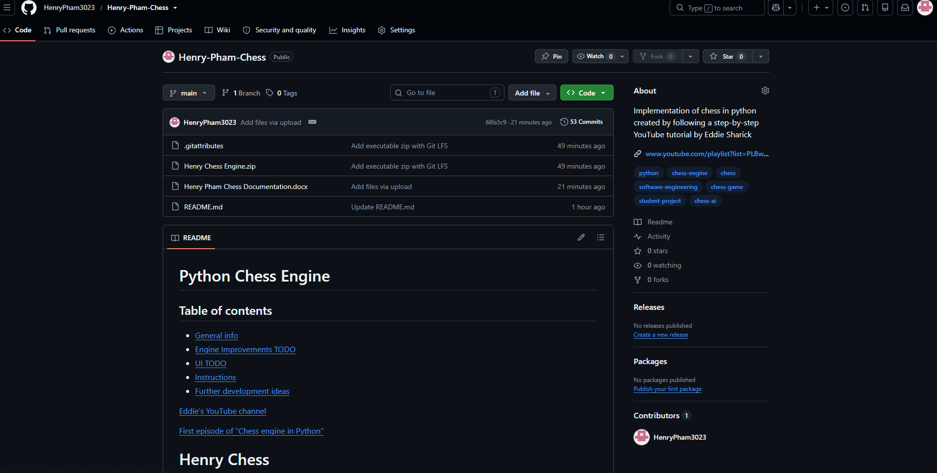
Figure 23.1. GitHub repository home page showing the public project, README, files and repository evidence.
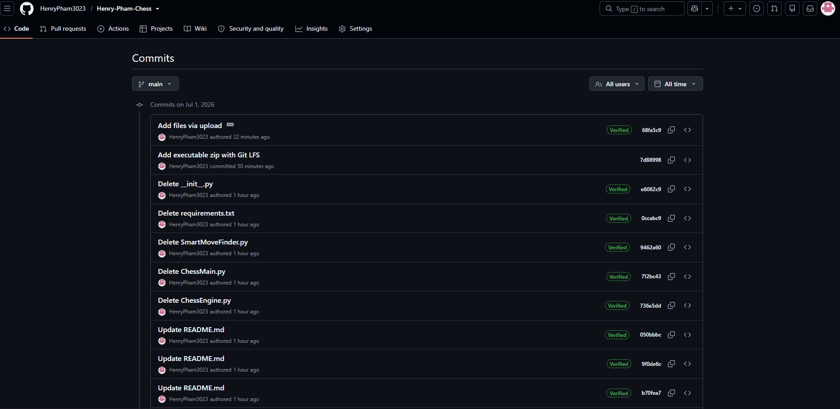
Figure 23.2. GitHub commit history showing repeated commits and version-control management.
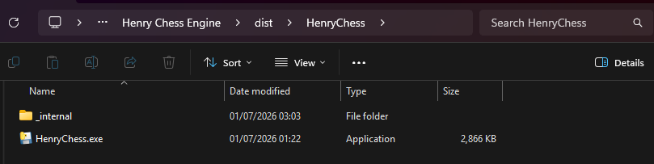
Figure 23.3. PyInstaller dist folder showing the packaged executable and internal support folder.
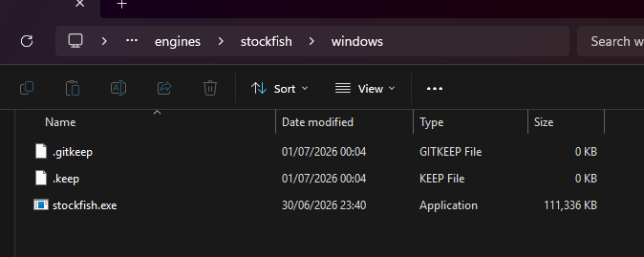
Figure 23.4. Stockfish Windows folder showing stockfish.exe placed correctly for Game Review and high-rated bots.
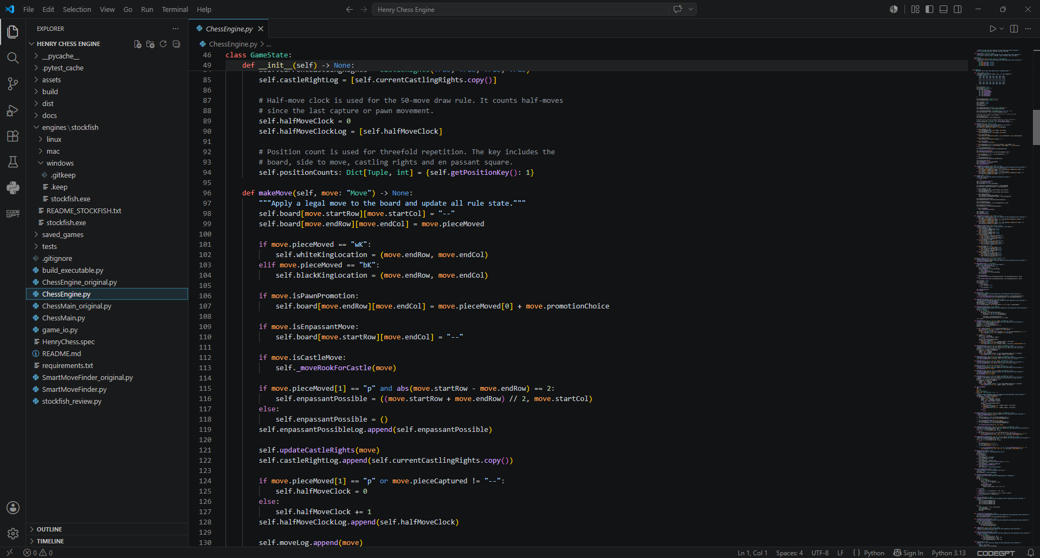
Figure 23.5. VS Code project structure and commented ChessEngine.py source code.

Figure 23.6. Graphical annotation / premove-style arrow evidence showing interactive board planning tools.
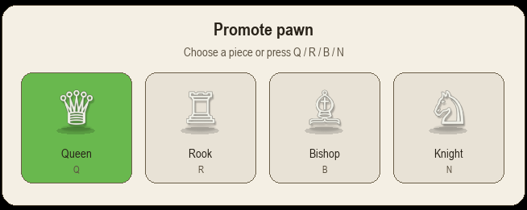
Figure 23.7. Pawn promotion popup showing Queen, Rook, Bishop and Knight with images and names.
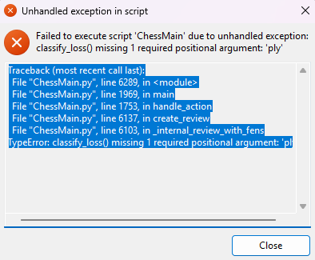
Figure 23.8. Historical error evidence used during debugging, showing how traceback information guided fixes and refinement.

24. Directory Structure and Module Responsibility Expansion
The project structure supports the marking criteria by separating implementation, assets, engines, documentation, tests and executable build artefacts. This also makes the project easier to maintain and assess.
Henry Chess Engine/
|-- ChessMain.py # Main Pygame app, screens, buttons, game loop and user input
|-- ChessEngine.py # Board state, legal move generation and chess rule enforcement
|-- SmartMoveFinder.py # Internal AI, bot move selection and difficulty behaviour
|-- stockfish_review.py # UCI Stockfish analysis, move labels and review data
|-- game_io.py # PGN/FEN import, PGN export and file handling
|-- build_executable.py # PyInstaller build automation
|-- HenryChess.spec # Executable build configuration
|-- requirements.txt # Python dependencies
|-- README.md # User instructions and project overview
|-- assets/ # Pieces, sounds, bot icons and UI images
|-- engines/stockfish/ # Optional Stockfish binaries for Windows/Mac/Linux
|-- saved_games/ # Export/import folder for PGN/FEN evidence
|-- tests/ # pytest unit/regression tests
|-- docs/ # Code standards, AI usage, Stockfish notes and rubric mapping
|-- dist/ # Built executable output folder

25. Secure Programming and Defensive Handling Expansion

25.1 Desktop-app security relevance
Because Henry Chess is a desktop app, web-only controls such as CSRF tokens, SQL injection prevention, password hashing and HTTPS are not the main security risks. The relevant secure programming requirements are defensive data handling, graceful error handling, external process safety and race condition management.
Risk area | Implementation strategy | Assessment relevance
Invalid moves | Only moves found in legalMoves are executed; illegal moves are rejected. | Input validation and defensive handling.
Invalid PGN/FEN import | Import logic checks input format and avoids crashing on malformed files. | Graceful error handling.
Missing Stockfish | The app falls back to internal evaluation if Stockfish is missing or fails. | Exception management.
AI freezing UI | AI moves are delayed/scheduled so the game loop remains interactive. | Race condition and responsiveness control.
Puzzle index errors | Puzzle solution steps are checked before access to avoid list index crashes. | Robust edge-case handling.
Executable missing files | Build documentation instructs users not to move the exe out of the folder and keeps assets bundled. | Deployment reliability.
Copyright/source risk | Third-party tools and tutorial inspiration are acknowledged. | Academic integrity and source acknowledgement.

26. Expanded Testing and Evaluation Plan

26.1 Testing strategy
Testing was planned across four layers: unit testing, manual feature testing, regression testing after fixes, and usability testing through live gameplay. This is necessary because a chess program can pass simple movement tests but still fail in UI interaction, timer behaviour, puzzle sequences or Stockfish review.
Test category | Examples tested | Expected result
Unit tests | Legal moves, special moves, AI fallback, Stockfish review fallback, file handling. | pytest passes without failures.
Manual gameplay tests | Local game, Vs AI, side selection, time control, board flip, promotion, checkmate. | Game remains playable and rules are enforced.
Puzzle tests | Correct move, wrong move, opponent auto-reply, solved puzzle state. | Correct moves green, wrong moves red/reset, no index crash.
Game review tests | Review after checkmate/timeout, clickable move list, best move arrow, accuracy. | Review loads without closing and displays reviewed player moves.
Bot tests | Low bot, mid bot, high bot, Mr Zhukov, 2400/2600 bot. | Bot behaviour scales through rating and Stockfish use.
Executable tests | Run from dist folder, check assets and Stockfish folder. | App opens outside VS Code.
Usability tests | Menu spacing, readable text, move log scroll, mouse-only premove. | No text overflow and all core actions are accessible.

26.2 Edge cases tested
- Attempting to move a pinned piece that exposes the king.
- Attempting to castle through check or after a rook/king moved.
- Promoting a pawn and selecting a promoted piece from the popup.
- Using hint during opponent turn or AI turn.
- Setting a premove and verifying it only executes if legal.
- Timing out during a match and confirming the game ends properly.
- Opening Game Review after checkmate and after timeout.
- Importing PGN/FEN from saved_games and rejecting invalid data.
- Running without Stockfish to confirm fallback behaviour.
- Running with Stockfish in the correct platform folder.

27. GitHub and Version Control Expansion
The GitHub repository demonstrates project management through commits, README documentation and executable distribution planning. The latest screenshot shows a public repository with 53 commits, README content, uploaded documentation and executable ZIP evidence. This supports the requirement for GitHub evidence and project management over time.

27.1 GitHub workflow
- Develop feature or bug fix locally in VS Code.
- Run manual game checks and automated tests where relevant.
- Commit the change with a meaningful message describing the feature or fix.
- Push to GitHub so the change becomes part of the project history.
- Update README/documentation when a major feature or setup step changes.
- Use Git LFS or GitHub Releases for large executable ZIP files.

27.2 Commit evidence interpretation
The commit history screenshot provides evidence of repeated refinement. Examples shown include README updates, file management, executable ZIP handling and project restructuring. These commits demonstrate version control, although the final documentation should also explain the purpose of major commits so the marker can understand how the repository developed beyond the file names alone.

28. Expanded Process Diary / Logbook
This logbook summarises the major development stages. Dates should be checked against the final GitHub commit history before submission so the documentation remains consistent with the repository evidence.
Period | Focus | Development work | Testing/reflection
Feb 2026 Week 1 | Project selection and problem definition | Selected chess engine as an advanced app project. Defined target users as students, chess club members and teachers. | Confirmed project had enough complexity for rules, AI, UI and testing.
Feb 2026 Week 2 | Requirements planning | Drafted functional requirements for legal moves, checkmate, AI and UI. Listed non-functional requirements for performance, maintainability and usability. | Realised special moves would need careful rule state tracking.
Mar 2026 Week 1 | Board and pieces | Built initial board representation and piece drawing. Tested simple movement and board layout. | Needed clearer separation between board state and UI drawing.
Mar 2026 Week 2 | Legal move engine | Expanded move generation and filtering so illegal king-exposing moves would be rejected. | Move legality became the most important engine reliability requirement.
Mar 2026 Week 3 | Special chess rules | Added castling, en passant, promotion and move logging. | Special rules required move history and additional state variables.
Apr 2026 Week 1 | Basic AI | Implemented AI move selection and bot move handling. | AI needed to avoid freezing interface and needed different strength levels.
Apr 2026 Week 2 | UI redesign | Improved menu screens, sidebar buttons, clocks and move log. | User feedback showed that cramped UI reduced usability.
Apr 2026 Week 3 | Rated bots | Added rating-style bots with different profiles and stronger behaviour at higher ratings. | Bot ratings needed opening variety and stronger calculation for high levels.
May 2026 Week 1 | Puzzle training | Implemented puzzle menu and puzzle move validation. | Found that puzzle indexes and opponent replies needed defensive handling.
May 2026 Week 2 | Stockfish review | Integrated Stockfish through UCI and designed move-by-move review structure. | Stockfish path handling needed platform-specific folders and fallback logic.
May 2026 Week 3 | Game Review UI | Added clickable reviewed move list, board state preview, arrows, labels, accuracy and graph. | Review needed to focus on human moves in bot games to reduce load time.
June 2026 Week 1 | Usability polish | Added premove button, annotations, promotion popup, rules guide and theme controls. | Mouse-only access improved usability for players.
June 2026 Week 2 | Testing and bug fixing | Fixed puzzle crash, game review crash, bot rating overflow and timeout handling. | Regression testing was needed after each UI or engine change.
June 2026 Week 3 | Executable packaging | Built the project with PyInstaller and checked dist folder output. | Executable must stay with _internal/assets/engines folders.
June 2026 Week 4 | GitHub and documentation | Updated README, uploaded documentation, configured Git LFS/release strategy for large ZIP. | GitHub evidence supports project management and handover.
July 2026 Week 1 | Presentation preparation | Prepared PowerPoint and live demo sequence. | Presentation should focus on problem, tools, design, testing, challenges and live demo.
July 2026 Week 2 | Final refinement | Checked visuals, comments, source acknowledgement and rubric alignment. | Final project should be tested from a fresh folder before submission.
July 2026 Week 3 | Submission check | Reviewed zip contents, executable folder, docs, slides and GitHub link. | Single zip submission should include all required artefacts.
July 2026 Week 4 | Post-deadline extension/evaluation period | Documented future improvements and evaluated strengths/limitations. | Reflection identifies online multiplayer, stronger opening book and improved assets as future work.

29. Copyright, Source Acknowledgement and Academic Integrity Expansion

29.1 Eddie Sharick acknowledgement
The project acknowledges Eddie Sharick’s chess engine tutorial/video series as an initial learning resource and inspiration for understanding how a Python chess engine can be structured. The final submitted project was significantly modified and extended through new UI systems, rated bots, Stockfish review, practice mode, puzzles, rules guide, premoves, annotations, executable packaging, documentation and testing.

29.2 Third-party tools and assets
Source/tool | Use in project | Acknowledgement requirement
Eddie Sharick chess engine video/tutorial | Learning foundation for chess engine concepts. | Acknowledge on title slide, README and documentation.
Pygame | Desktop window, drawing, mouse input and sound. | List in requirements and acknowledgements.
Stockfish | Optional engine for review and strong bots. | Acknowledge as third-party open-source UCI engine.
PyInstaller | Executable packaging. | List as build/deployment tool.
GitHub | Version control and distribution. | Reference repository link.
Bot/piece/audio assets | Visual and sound assets used in prototype. | Confirm copyright-free/licensed status or replace/acknowledge before final submission.
Important submission note: any copyrighted prototype images visible in screenshots or assets should be replaced with original/licensed assets or clearly acknowledged before final submission.

30. Presentation and Live Demonstration Plan
The assessment requires an 8-15 minute presentation with 9-16 slides, GitHub reference and a preferred live demo. The presentation should not simply list features; it should tell the story of how the project moved from problem definition to engineered solution.
Demo step | What to show | Why it matters
1. Open executable | Open HenryChess.exe from dist folder. | Shows deployment outside the IDE.
2. Play setup | Choose Vs AI, side, bot rating and time control. | Shows usability and mode selection.
3. Gameplay | Make a legal move, show clock, move log and AI reply. | Shows working chess engine and interactivity.
4. Premove/annotation | Draw an arrow or set a premove. | Shows advanced interactive features.
5. Practice bots | Show bot ratings including high-rated bots. | Shows differentiated AI practice.
6. Puzzle mode | Open a puzzle and explain correct/incorrect feedback. | Shows training functionality.
7. Game Review | Open Stockfish review and click a move. | Shows advanced evaluation and feedback.
8. GitHub evidence | Show repo, commits, README and documentation. | Shows project management and submission readiness.

31. Final Template Checklist
Checklist item | Status in final documentation
Cover page with title, name, course, teacher, GitHub, date and version | Included / update personal fields before final submission.
Automatic or updateable table of contents | Heading styles used; update TOC in Word after final edits.
Problem statement and purpose | Expanded in Section 18.
Methodology and sprint plan | Expanded in Section 19.
Functional and non-functional requirements | Expanded in Section 20.
Stakeholder analysis | Expanded in Section 19.3.
Gantt chart and risk management | Included in original documentation and expanded in Section 19.4.
Technology justification | Expanded in Section 21.
Architecture, UML, flowcharts and pseudocode | Original diagrams included; expanded explanation and pseudocode in Section 22.
Wireframe/storyboard evidence | Desktop UI storyboard explanation and screenshots included.
Directory structure | Expanded in Section 24.
Secure programming | Expanded in Section 25.
Testing evidence | Expanded in Section 26.
GitHub management | Expanded in Section 27 with screenshots.
Process diary/logbook | Expanded in Section 28.
Reflection and future improvements | Included in original documentation and presentation plan.
Copyright and source acknowledgement | Expanded in Section 29.

